St. John Evangelical Lutheran Church Sunday, June 26, 2022
229 South Broad Street 3rd Sunday after Pentecost
Jersey Shore, PA 17740
570-398-1676
Of the Land and Seasons
A Folk-Song Paraphrase Setting of Holy Communion
A Quarterly Observance of Prayer and Holy Communion drawn from Life on the Farm and Orchard
Prepared by The Reverend Stephen P. Folkemer, M.S.M., D Min.
The Rev. Beth Bergeron Folkemer

SHARING OUR JOYS AND CONCERNS
Prelude
Gathering
The Holy Spirit calls us together as the people of God.

Confession and Forgiveness
The assembly stands. All may make the sign of the cross, the sign that is marked at baptism, as the presiding minister begins.
P: In the name of the Father, and the (☩) Son, and of the Holy Spirit.
C: Amen
P: Almighty God, to whom all hearts are open, all desires know, and from who no secrets are hid: Cleanse the thoughts of our hearts by the inspiration of your Holy Spirit, that we may perfectly love you and worthily magnify your holy name, through Jesus Christ our Lord
C: Amen
P: Most merciful God,
C: we confess that we are in bondage to sin and cannot free ourselves. We have sinned against you in thought, word and deed, by what we have done and by what we have left undone.
We have neglected to nurture the new growth you cause to sprout among us. We have failed to protect those tender and vulnerable in faith from the choking weeds of our indifference and inflexibility. For the sake of your Son, Jesus Christ, have mercy on us. Forgive us, rededicate us, and compel us, so that we may delight in your will and walk in your ways, to the glory of your holy name. Amen.
P: Almighty God, in his mercy, has given us his Son to die for us and, for his sake, forgives us all our sins. As a called and ordained minister of the Church of Christ, and by his authority, I therefore declare to you the entire forgiveness of all your sins, in the name of the Father, and of the (☩) Son, and of the Holy Spirit.
C: Amen

Gathering Song: Joyful, Joyful, We Adore Thee 836

Greeting
P: The grace of our Lord Jesus Christ, the love of God,
and the communion of the Holy Spirit be with you all.
C: And also, with you.

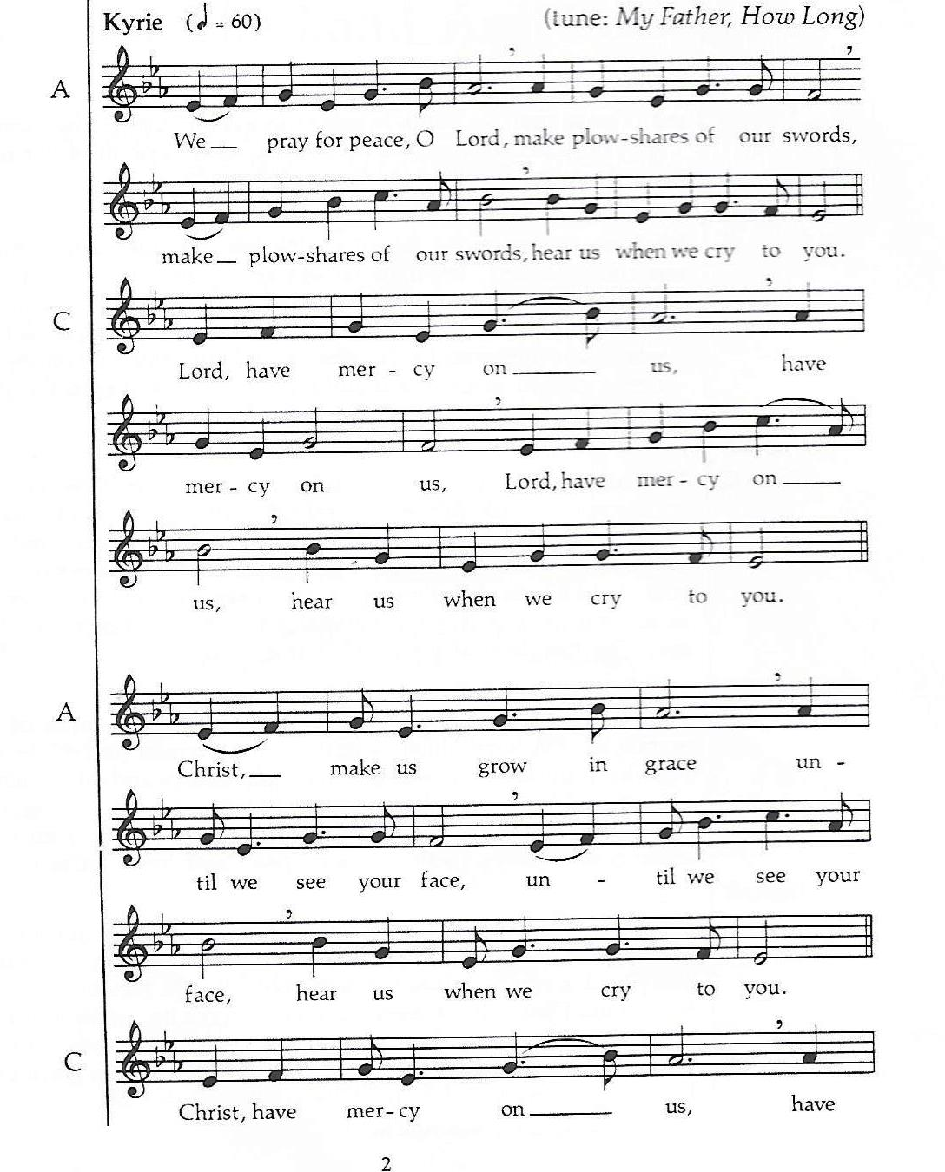
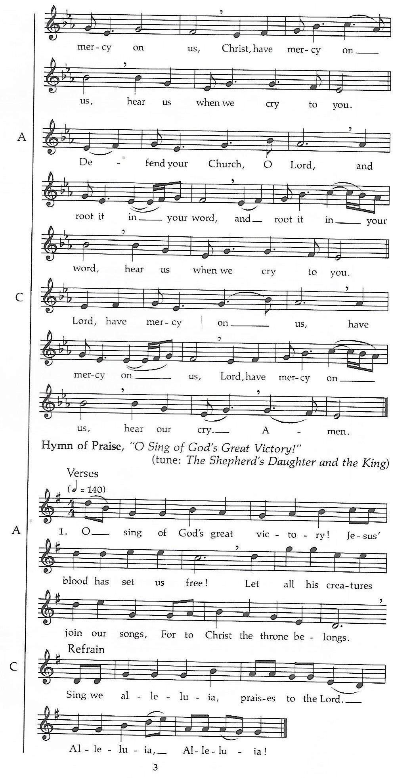
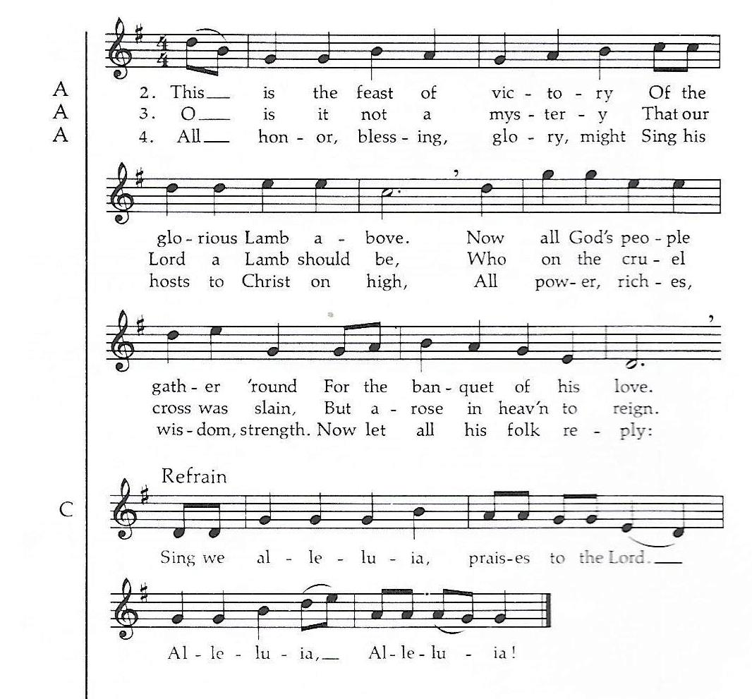

Prayer of the Day
P: Let us pray.
Sovereign God, ruler of all hearts, you call us to obey you, and you favor us with true freedom. Keep us faithful to the ways of your Son, that, leaving behind all that hinders us, we may steadfastly follow your paths, through Jesus Christ, our Savior and Lord.
Amen.

The assembly is seated.

Word
God speaks to us in scripture reading, preaching, and song.

L: A reading from First Kings

First Reading: 1 Kings 19:15-16, 19-21
In the story preceding today’s reading, the prophet Elijah flees for his life to the security of God’s mountain. There God reveals to Elijah that there are still other faithful people in Israel and commissions him to anoint new leaders, including his own successor, Elisha.

¹⁵Then the Lord said to [Elijah,] “Go, return on your way to the wilderness of Damascus; when you arrive, you shall anoint Hazael as king over Aram. ¹⁶Also you shall anoint Jehu son of Nimshi as king over Israel; and you shall anoint Elisha son of Shaphat of Abel-meholah as prophet in your place.
¹⁹So he set out from there, and found Elisha son of Shaphat, who was plowing. There were twelve yoke of oxen ahead of him, and he was with the twelfth. Elijah passed by him and threw his mantle over him. ²⁰He left the oxen, ran after Elijah, and said, “Let me kiss my father and my mother, and then I will follow you.” Then Elijah said to him, “Go back again; for what have I done to you?” ²¹He returned from following him, took the yoke of oxen, and slaughtered them; using the equipment from the oxen, he boiled their flesh, and gave it to the people, and they ate. Then he set out and followed Elijah, and became his servant.

L: The word of the Lord.
C: Thanks be to God.

Psalm: 16

¹Protect me, O God, for I take refuge in you;
I have said to the Lord, “You are my Lord, my good above all other.”
²All my delight is in the godly that are in the land,
upon those who are noble among the people.
³But those who run after other gods
shall have their troubles multiplied.
⁴I will not pour out drink offerings to such gods,
never take their names upon my lips.
⁵O Lord, you are my portion and my cup;
it is you who uphold my lot.
⁶My boundaries enclose a pleasant land;
indeed, I have a rich inheritance.
⁷I will bless the Lord who gives me counsel;
my heart teaches me night after night.
⁸I have set the Lord always before me;
because God is at my right hand, I shall not be shaken.
⁹My heart, therefore, is glad, and my spirit rejoices;
my body also shall rest in hope.
¹⁰For you will not abandon me to the grave,
nor let your holy one see the pit.
¹¹You will show me the path of life;
in your presence there is fullness of joy, and in your right hand are pleasures forevermore.

L: A reading from Galatians.

Second Reading: Galatians 5:1, 13-25
For Paul, the freedom Christ gives is not permission to do whatever we want. It is the invitation to be what we could not be otherwise. The power and guidance of Christ’s Holy Spirit produce a different kind of life, one marked by the fruit of this Holy Spirit.

¹For freedom Christ has set us free. Stand firm, therefore, and do not submit again to a yoke of slavery.
¹³For you were called to freedom, brothers and sisters; only do not use your freedom as an opportunity for self-indulgence, but through love become slaves to one another. ¹⁴For the whole law is summed up in a single commandment, “You shall love your neighbor as yourself.” ¹⁵If, however, you bite and devour one another, take care that you are not consumed by one another.
¹⁶Live by the Spirit, I say, and do not gratify the desires of the flesh. ¹⁷For what the flesh desires is opposed to the Spirit, and what the Spirit desires is opposed to the flesh; for these are opposed to each other, to prevent you from doing what you want. ¹⁸But if you are led by the Spirit, you are not subject to the law. ¹⁹Now the works of the flesh are obvious: fornication, impurity, licentiousness, ²⁰idolatry, sorcery, enmities, strife, jealousy, anger, quarrels, dissensions, factions, ²¹envy, drunkenness, carousing, and things like these. I am warning you, as I warned you before: those who do such things will not inherit the kingdom of God.
²²By contrast, the fruit of the Spirit is love, joy, peace, patience, kindness, generosity, faithfulness, ²³gentleness, and self-control. There is no law against such things. ²⁴And those who belong to Christ Jesus have crucified the flesh with its passions and desires. ²⁵If we live by the Spirit, let us also be guided by the Spirit.

L: The word of the Lord.
C: Thanks be to God.

The assembly stands.

P: The holy gospel according to St. Luke, the 9th chapter.
C: Glory to you, O Lord.

Gospel: Luke 9:51-62
Jesus is unwavering in his commitment to his mission in Jerusalem and will not be swayed by pettiness. In a series of striking cases in point, he calls his disciples to a similar single-mindedness.

⁵¹When the days drew near for [Jesus] to be taken up, he set his face to go to Jerusalem. ⁵²And he sent messengers ahead of him. On their way they entered a village of the Samaritans to make ready for him; ⁵³but they did not receive him, because his face was set toward Jerusalem. ⁵⁴When his disciples James and John saw it, they said, “Lord, do you want us to command fire to come down from heaven and consume them?” ⁵⁵But he turned and rebuked them. ⁵⁶Then they went on to another village.
⁵⁷As they were going along the road, someone said to him, “I will follow you wherever you go.” ⁵⁸And Jesus said to him, “Foxes have holes, and birds of the air have nests; but the Son of Man has nowhere to lay his head.” ⁵⁹To another he said, “Follow me.” But he said, “Lord, first let me go and bury my father.” ⁶⁰But Jesus said to him, “Let the dead bury their own dead; but as for you, go and proclaim the kingdom of God.” ⁶¹Another said, “I will follow you, Lord; but let me first say farewell to those at my home.” ⁶²Jesus said to him, “No one who puts a hand to the plow and looks back is fit for the kingdom of God.”

P: The gospel of the Lord.
C: Praise to you, O Christ.

The assembly is seated.

Sermon

Hymn of the Day: Amazing Grace 779

Apostles Creed ( p. 105 at the beginning of the hymnal)

Prayers of Intercession
A: United in Christ and guided by the Spirit, we pray for the church, the creation, and all in need.
A brief silence.
A: of faithfulness, set the face of your church firmly on you. Rooted in your self-giving love, may the church find freedom in loving our neighbors. God of grace,
C: hear our prayer.
A: God of gentleness, strengthen the earth’s ability to heal. Where there are dangerous storms, bring calm. Where there are destructive fires, bring rain. Protect homes, habitats, and livelihoods threatened by climate disasters. God of grace,
C: hear our prayer.
A: God of peace, guide all who govern, that they place the good of their citizens above self-promotion. Anoint leaders of nations with your Spirit of neighborly love. Protect refugees and all who live under tyranny or conflict (especially). God of grace,
C: hear our prayer.
A: God of kindness, reveal your healing presence to all who are sick or dying (especially). Uphold those who grieve. Support the needs of any who are unemployed, hungry, or have nowhere to lay their heads. God of grace,
C: hear our prayer.
A: God of love, attend to those struggling with addiction, depression, or uncontrolled anger. Provide support systems and loving companions as they work toward health, that they may rest in hope and know the fullness of joy in your presence. God of grace,
C: hear our prayer.
A: God of the world, we pray for our sisters and brothers in Germany as we give thanks for our companion synod partnership that has existed since the mid 1980’s. We pray for the Lutheran Churches throughout Franconia, Germany, who are hosting refugees from Ukraine and providing them with the support they need. We pray as well for Bishop Gisela Bornowski who is leading the Ansbach-Würzburg Kirchenkreis through these challenging times and as the congregations celebrate this season of Pentecost. O Lord, may your Holy Spirit give them strength to meet these challenges. God of grace
C: hear our prayer.
Here other intercessions may be offered.
A: God of joy, we give thanks for all who have died and now celebrate the inheritance of life in you. Keep their examples of faithfulness always before us, that we trust your promises in life and in death. God of grace,
C: hear our prayer.
P: God of every time and place, in Jesus’ name and filled with your Holy Spirit, we entrust
these spoken prayers and those in our hearts into your holy keeping.
C: Amen.

P: The peace of the Lord be with you always.
C: And also with you.

Responding in Love

Our Offerings This is our response to God's grace.

The assembly stands.

OFFERTORY HYMN
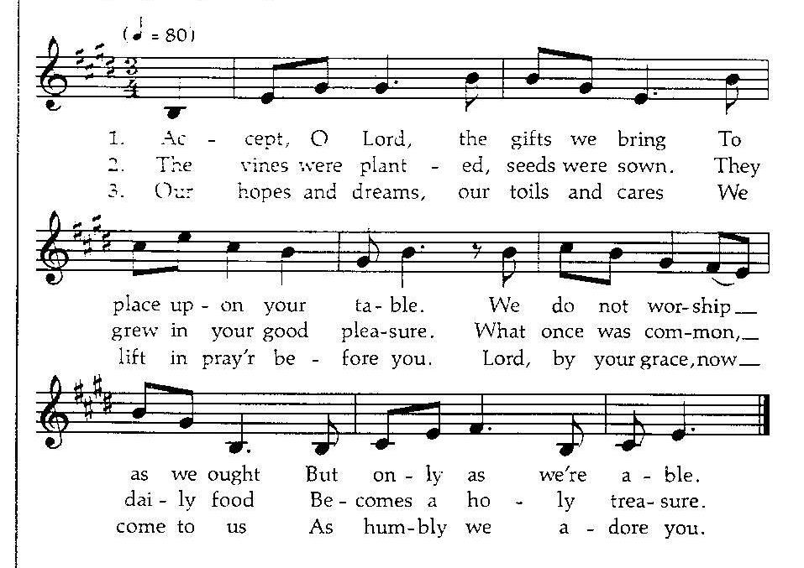
Offering Prayer
A: Let us pray. Gracious God,
P: Let us give thanks to the Lord our God.
C: It is right to give him thanks and praise.
P: It is indeed right and salutary that we should at all times and in all places offer thanks and praise to you, O Lord, holy Father, Through Christ our Lord…….. we praise your name and join in adoring song:

Thanksgiving at the Table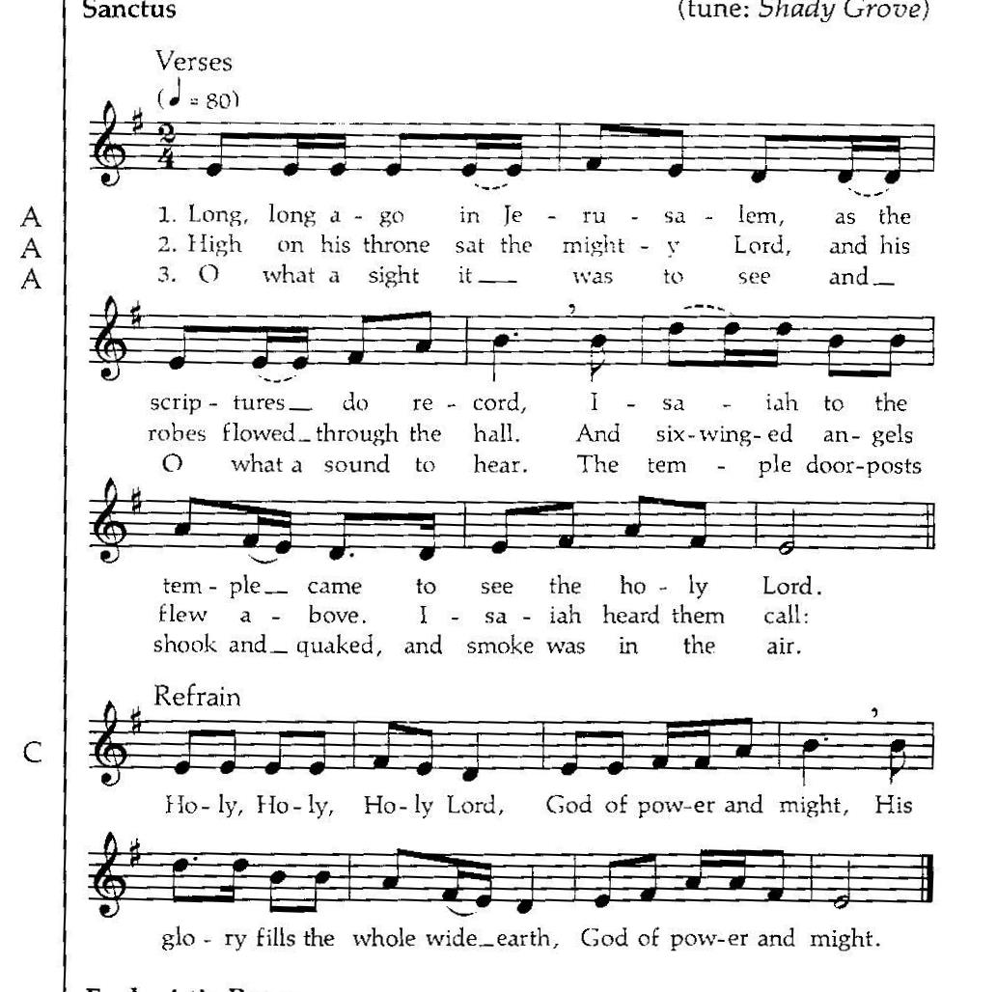
Words of Institution

Blessed are you, O God, creator of heaven and earth.
C: you bless us with gifts of guidance, new life, growth in grace, and fruitful labor. Accept the first fruits of time and toil, field and orchard we offer here. Bless and multiply these gifts to our nurture and the care of your creation: for the sake of your Son, Jesus Christ our Savior. Amen.

GREAT THANKSGIVING
P: The Lord be with you.
C: And also with you.
P: Lift up your hearts.
C: We lift them to the Lord.

You rescued your covenant people, led them on all their journeys,
and taught them by the prophets.
You so loved the world that you gave your only Son,
so that everyone who believes in him may not perish but may have eternal life

In the night in which he was betrayed,
our Lord Jesus took bread, and gave thanks;
broke it, and gave it to his disciples, saying:
Take and eat; this is my body, given for you.
Do this for the remembrance of me.

Again, after supper, he took the cup, gave thanks,
and gave it for all to drink, saying:
This cup is the new covenant in my blood,
shed for you and for all people for the forgiveness of sin.
Do this for the remembrance of me.

As often as we eat this bread and drink this cup,
we proclaim the Lord’s death until he comes:
Christ has died.
Christ is risen.
Christ will come again.

Pour out your Holy Spirit in this meal,
and make us one in this community
of faith and with your people throughout the world.

Glory and praise to you, O God,
Author of life, Word made flesh,
Power of the Most High, now and forever.
Amen.

THE LORD’S PRAYER P 145 (in the beginning of the hymnal)

Invitation to Communion
P: In Christ’s presence there is fullness of joy.
Come to the banquet.

Communion
When giving the bread and cup, the communion ministers say
The body of Christ, given for you.
The blood of Christ, shed for you.
and each person may respond Amen. 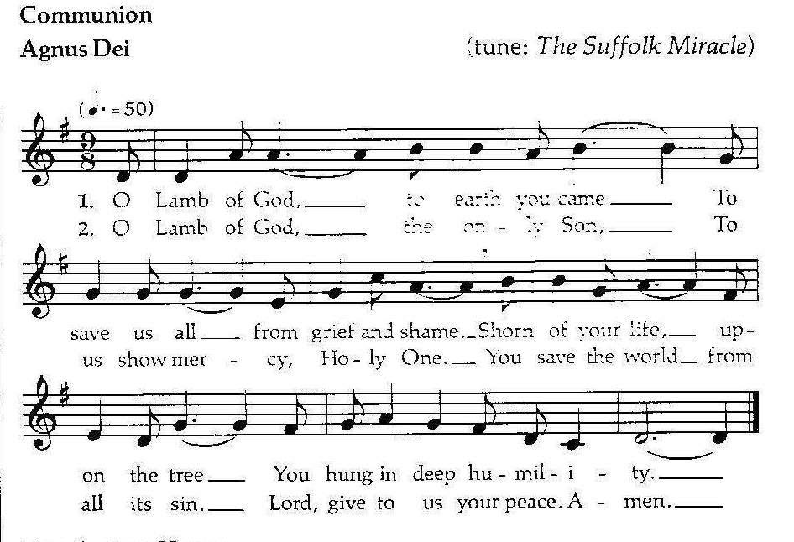
Song after Communion
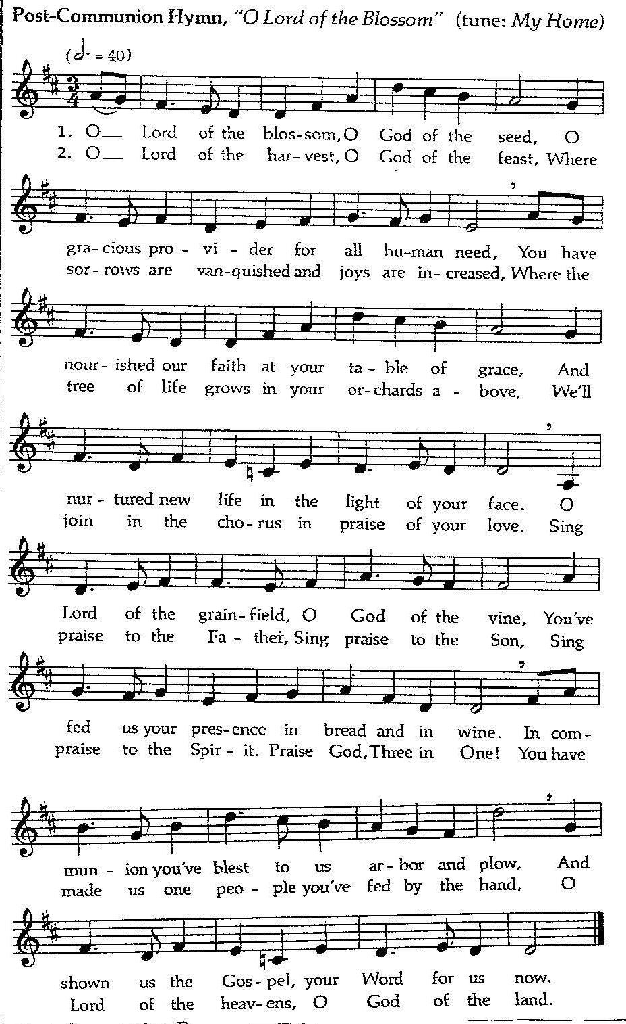

Prayer after Communion
A: Let us pray. Gracious God, we give thanks for your pruning, planting, and nurture. We rejoice that you have used the harvest of field and vineyard to renew and sustain us. Lead us as we go from this life-giving meal into lives of grateful service to you and your cherished creation; through Jesus Christ, you Son, our Lord C: AMEN

Blessing
P: The Lord bless you and keep you, the lord make his face shine on you and be gracious to you. The Lord look upon you with favor and ☩ give you peace.
C: Amen.

Sending Song: Great is Thy Faithfulness 733

Dismissal
P: Go in peace. Serve the Lord
C: Thanks be to God.
Announcements
We welcome our visitors and ask that you sign a Visitor Attendance and Holy Communion Card that is located in the pew rack. We ask that cards be returned via the offering plate during the receiving of the offering. We practice “open Communion” here at St. John meaning that all who believe in the “real presence” of Christ are welcomed to receive the Sacrament of Holy Communion. We offer two choices for Holy Communion, wine or grape juice. Those worshipers desiring grape juice are asked at the communion rail to place their right hand over their heart after receiving “The Body of Christ.”

Remember in prayer: Rowan Aldridge, Dave Barner, Mary Bower, Mike Cervinsky, Agnes Cryder, Don Delaney, Mary Ellen Dougherty, Charlie Dunne, Joanne Fisher, William Greene, Fred Hoffer, Mick Miller, David Mitchell, Mary Lynn Overdorf, the Snyder family, John Truax, and all of our shut-ins; the safety of our military troops around the world (Mark Baier, Isaac Boring, Jake Cordrey, Ben Cramer, Patrick Hamlin, Paul Laidacker, Kenny Leitch, Steven Moore, Maddison Myers, Tyler O’Neal, Adam Shaffer, Richie Speicher, Aaron Stabley, Paul St. James, Jenna White); Family Promise. Bishop Eaton, our Presiding Bishop; and Bishop Collins, Bishop of the Upper Susquehanna Synod. For our Companion Synod in Liberia and Ansbach-Wurzburg, Germany. Pray for Peace in Ukraine and an end to war.

Special thanks to this week’s helper: Lector –Deb Heydrich; Assisting Ministers—Joyce Braucht and Carl Schaefer; Head Usher –Deb Heydrich; Teller – Cozette Stoltzfus; Bulletin Sponsor – Cindy Breon;

Next week’s helpers: Lector –Kathy Brundick; Assisting Ministers –Deb Heydrich and Ron Brundick; Head Usher –Dawn McCloskey; Teller – Shane Snyder; Bulletin Sponsor – Darlene Bilby; Flowers Joyce Braucht..

The flowers are given by Dean and Barb Hoffman in memory of loved ones.

The Sanctuary Candle is given in memory of her husband by Myrtle Long

Payments for Sight and Sound “DAVID” February 6 - $65.00; May 1 - $65.00 and the final payment June 17 - $60 Fare includes bus, play, meal, tip for driver and fund raiser for Luke Antolick. The show is August 6, 2022 -- Children 10 and under $125.00; Adults $190.00. Joyce Braucht.

The Lutheran Church Women’s Prayer Chain is a vital ministry of St. John Lutheran.
Anyone in need of prayers is asked to contact any of the following persons:
Gloria Ely – 570-873-3597 Sarah Davidson - 570-398-0659 Joyce Braucht - 570-398-2852
VACATION BIBLE SCHOOL (VBS) is at St Johns this year! Registration and making name tags will be Sunday, July 17 at 6:00 p.m. We need CHILDREN! Your children, your grandchildren, your nieces and nephews, the neighbor’s child, the neighbor’s grandchildren! Also needed are teen helpers. Sunday, July 17 – Thursday, July 21 at 6 PM. More information will be posted! So, watch this space!

Greetings everyone,
Just wanted to reach out to everyone and let you know we will be having our annual St. James Day celebration on Sunday, July 24th. Following the worship service (usually around noon), we will host our St. James' Day picnic and would like to invite our worship leaders and the members of the congregations of St. John, Garman and Grace to join us. We had scaled back on the picnic the last couple years due to COVID, but council voted to once again invite the other churches. St. James will provide paper goods, fried chicken, and we usually provide water, iced tea or lemonade as the beverages.
Please leave a message at the church office (570-916-1317) or tell Pastor Aucker if you are attending by July 17.
We just want to be sure to order enough chicken. We also ask that you bring a dish or dessert to share, and your own beverage if you don't want water, tea or lemonade. The last two years we have set the food line up indoors in our fellowship area and had tables available to eat at in both the fellowship area and under the pavilion. Sometimes the weather is very warm, and some guests would rather stay inside in the air conditioning to eat.
We hope to see many faces we have not seen in a few years!
Blessings, Sheri at St. James

Dear Trinity Lutheran Avis Endowment Scholarship Fund,
Thank you for selecting me as one of this year’s recipients. This scholarship will help me greatly as I enter my third year of college.
Thank you,
Olivia-Anne Eisner

THIS WEEK’S EVENTS
Sunday, June 26, 2022 3rd Sunday after Pentecost 9:30 a.m. Nave Worship Service Land and Seasons
Wednesday, June 29, 2022
10:00 a.m. Trinity Episcopal Worship
Sunday, July 3 2022 4th Sunday after Pentecost
9:30 a.m. Nave Worship Service

