St. John Evangelical Lutheran Church Sunday, July 24, 2022
229 South Broad Street
Jersey Shore, PA 17740 7th Sunday after Pentecost
570-398-1676

Introduction to the day
Persistence in prayer is encouraged by Jesus and wins the attention of God when Abraham intercedes for Sodom. The life of the baptized—to be rooted and built up in Christ Jesus—is to be nurtured with prayer. God hears and answers prayer and so strengthens God’s own. “When I called, you answered me; you increased my strength within me.”

SHARING OUR JOYS AND CONCERNS

Gathering
The Holy Spirit calls us together as the people of God.

Confession and Forgiveness
The assembly stands. All may make the sign of the cross, the sign that is marked at baptism, as the presiding minister begins.

Blessed be the holy Trinity,☩ one God,
whose steadfast love endures forever.
Amen.
Let us confess our sin in the presence of God and of one another.
Silence is kept for reflection.
Merciful God,
we confess that we have not followed your path
but have chosen our own way.
Instead of putting others before ourselves,
we long to take the best seats at the table.
When met by those in need,
we have too often passed by on the other side.
Set us again on the path of life.
Save us from ourselves
and free us to love our neighbors.

Hear the good news!
God does not deal with us according to our sins
but delights in granting pardon and mercy.
In the name of ☩ Jesus Christ, your sins are forgiven.
You are free to love as God loves. Amen.

GATHERING SONG: Lord of Light 688

Greeting
P: The grace of our Lord Jesus Christ, the love of God,
and the communion of the Holy Spirit be with you all.

C: And also, with you.

Hymn of PRAISE: What a Friend We Have in Jesus 742

Prayer of the Day
P: Let us pray.
Almighty and ever-living God, you are always more ready to hear than we are to pray, and you gladly give more than we either desire or deserve. Pour upon us your abundant mercy. Forgive us those things that weigh on our conscience, and give us those good things that come only through your Son, Jesus Christ, our Savior and Lord. Amen.

The assembly is seated.

Word
God speaks to us in scripture reading, preaching, and song.

L: A reading from Genesis

First Reading: Genesis 18:20-32
In today’s reading, Abraham undertakes the role of a mediator between God and sinful humanity. Appealing to God’s justice, Abraham boldly asks for mercy for the city of Sodom for the sake of the few righteous people there, including Abraham’s nephew, Lot.
²⁰Then the Lord said, “How great is the outcry against Sodom and Gomorrah and how very grave their sin! ²¹I must go down and see whether they have done altogether according to the outcry that has come to me; and if not, I will know.”
²²So the men turned from there, and went toward Sodom, while Abraham remained standing before the Lord. ²³Then Abraham came near and said, “Will you indeed sweep away the righteous with the wicked? ²⁴Suppose there are fifty righteous within the city; will you then sweep away the place and not forgive it for the fifty righteous who are in it? ²⁵Far be it from you to do such a thing, to slay the righteous with the wicked, so that the righteous fare as the wicked! Far be that from you! Shall not the Judge of all the earth do what is just?” ²⁶And the Lord said, “If I find at Sodom fifty righteous in the city, I will forgive the whole place for their sake.” ²⁷Abraham answered, “Let me take it upon myself to speak to the Lord, I who am but dust and ashes. ²⁸Suppose five of the fifty righteous are lacking? Will you destroy the whole city for lack of five?” And he said, “I will not destroy it if I find forty-five there.” ²⁹Again he spoke to him, “Suppose forty are found there.” He answered, “For the sake of forty I will not do it.” ³⁰Then he said, “Oh do not let the Lord be angry if I speak. Suppose thirty are found there.” He answered, “I will not do it, if I find thirty there.” ³¹He said, “Let me take it upon myself to speak to the Lord. Suppose twenty are found there.” He answered, “For the sake of twenty I will not destroy it.” ³²Then he said, “Oh do not let the Lord be angry if I speak just once more. Suppose ten are found there.” He answered, “For the sake of ten I will not destroy it.”
L: The word of the Lord.
C: Thanks be to God.

L: Let us read the Psalm responsively by verse.
Psalm: Psalm 138
¹I will give thanks to you, O Lord, with my whole heart;
before the gods I will sing your praise.
²I will bow down toward your holy temple and praise your name, because of your steadfast love and faithfulness;
for you have glorified your name and your word above all things.
³When I called, you answered me;
you increased my strength within me.
⁴All the rulers of the earth will praise you, O Lord,
when they have heard the words of your mouth.
⁵They will sing of the ways of the Lord,
that great is the glory of the Lord.
⁶The Lord is high, yet cares for the lowly,
perceiving the haughty from afar.
⁷Though I walk in the midst of trouble, you keep me safe;
you stretch forth your hand against the fury of my enemies; your right hand shall save me.
⁸You will make good your purpose for me;
O Lord, your steadfast love endures forever; do not abandon the works of your hands.

L: A reading from Colossians

Second Reading: Colossians 2:6-15 [16-19]
The writer of this letter warns the congregation in Colossae about “the empty lure” of philosophies and traditions that compromise faith. Through the gift of faith, the church is mystically connected with Christ in his death and resurrection which is enacted in baptism.
⁶As you therefore have received Christ Jesus the Lord, continue to live your lives in him, ⁷rooted and built up in him and established in the faith, just as you were taught, abounding in thanksgiving.
⁸See to it that no one takes you captive through philosophy and empty deceit, according to human tradition, according to the elemental spirits of the universe, and not according to Christ. ⁹For in him the whole fullness of deity dwells bodily, ¹⁰and you have come to fullness in him, who is the head of every ruler and authority. ¹¹In him also you were circumcised with a spiritual circumcision, by putting off the body of the flesh in the circumcision of Christ; ¹²when you were buried with him in baptism, you were also raised with him through faith in the power of God, who raised him from the dead. ¹³And when you were dead in trespasses and the uncircumcision of your flesh, God made you alive together with him, when he forgave us all our trespasses, ¹⁴erasing the record that stood against us with its legal demands. He set this aside, nailing it to the cross. ¹⁵He disarmed the rulers and authorities and made a public example of them, triumphing over them in it. [
¹⁶Therefore do not let anyone condemn you in matters of food and drink or of observing festivals, new moons, or sabbaths. ¹⁷These are only a shadow of what is to come, but the substance belongs to Christ. ¹⁸Do not let anyone disqualify you, insisting on self-abasement and worship of angels, dwelling on visions, puffed up without cause by a human way of thinking, ¹⁹and not holding fast to the head, from whom the whole body, nourished and held together by its ligaments and sinews, grows with a growth that is from God.]

L: The word of the Lord.
C: Thanks be to God.

The assembly stands.
Gospel Acclamation p.142
Alleluia Lord to whom shall we go?
You have the words of eternal life. Alleluia, Alleluia.

P: The holy gospel according to Luke
C: Glory to you, O Lord.

Gospel: Luke 11:1-13
In teaching his disciples this prayer, Jesus also reminds them to focus on God’s coming reign, God’s mercy, and the strengthening of the community. Jesus encourages his disciples to childlike trust and persistence in prayer.
¹[Jesus] was praying in a certain place, and after he had finished, one of his disciples said to him, “Lord, teach us to pray, as John taught his disciples.”²He said to them, “When you pray, say:
Father, hallowed be your name.
Your kingdom come.
³Give us each day our daily bread.
⁴And forgive us our sins,
for we ourselves forgive everyone indebted to us.
And do not bring us to the time of trial.”
⁵And he said to them, “Suppose one of you has a friend, and you go to him at midnight and say to him, ‘Friend, lend me three loaves of bread; ⁶for a friend of mine has arrived, and I have nothing to set before him.’ ⁷And he answers from within, ‘Do not bother me; the door has already been locked, and my children are with me in bed; I cannot get up and give you anything.’ ⁸I tell you, even though he will not get up and give him anything because he is his friend, at least because of his persistence he will get up and give him whatever he needs.
⁹“So I say to you, Ask, and it will be given you; search, and you will find; knock, and the door will be opened for you. ¹⁰For everyone who asks receives, and everyone who searches finds, and for everyone who knocks, the door will be opened. ¹¹Is there anyone among you who, if your child asks for a fish, will give a snake instead of a fish? ¹²Or if the child asks for an egg, will give a scorpion? ¹³If you then, who are evil, know how to give good gifts to your children, how much more will the heavenly Father give the Holy Spirit to those who ask him!”

The assembly is seated.

Sermon

Hymn of the Day: Sweet Hour of Prayer TTF 242
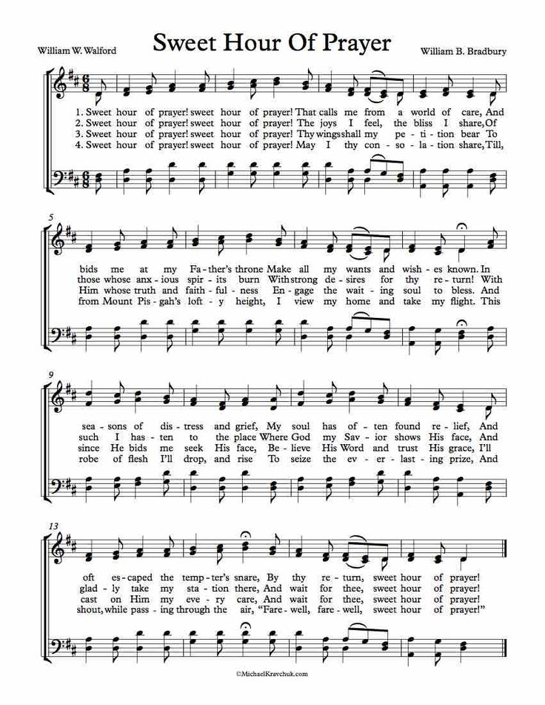

Apostles Creed ( p. 105 at the beginning of the hymnal)

Prayers of Intercession
The prayers are prepared locally for each occasion. The following examples may be adapted or used as appropriate.
A: Trusting in God’s extraordinary love, let us come near to the Holy One in prayer.
A brief silence.
Rooted and built up in Christ, we pray for the church. Embolden church leaders to take risks for the sake of the gospel, and equip the baptized to proclaim your extravagant love for the whole world. Merciful God,
C: receive our prayer.
A: Rejoicing in the works of your hands, we pray for the natural world. Make rivers and lakes, oceans and all waterways, sparkle with your radiance. Protect water sources (local water sources may be named) and strengthen those who defend them. Merciful God,
C: receive our prayer.
A: Interceding on behalf of the vulnerable, we pray for the peoples of the world. Inspire all rulers and governing authorities with your justice. Guide the work of legislators and public officials, that they advocate for the well-being of those they serve. Merciful God,
C: receive our prayer.
A: Persistent in prayer, we pray for our neighbors in need. To all who have hunger, give daily bread. To all who have bread, give hunger for justice. Open us to the cries of those who suffer (especially). Merciful God,
C: receive our prayer.
A: Abounding in thanksgiving, we pray for this congregation. Bless the prayer and fellowship ministries in this place. Call us together in times of praise and blessing, trouble and sorrow, in your holy name. Merciful God,
C: receive our prayer.
A: We lift up the ministry of Lutheran World Relief as they respond to the needs of your people around the world. School kits, health kits and blankets are used in disaster areas of the United States and around the world, especially in war torn areas. Help us to respond generously to give as we are able. Merciful God,
C: receive our prayer.
Here other intercessions may be offered.
A: Buried with Christ in baptism and raised with him to new life, we give thanks for your saints who rest in your eternal presence. Join our voices with theirs as we sing of your great glory. Merciful God,
C: receive our prayer.
P: Receive the prayers of your children, merciful God, and hold us forever in your steadfast love; through Jesus Christ, our holy Wisdom. Amen.

Responding in Love

Our Offerings This is our response to God's grace.

The assembly stands.
OFFERTORY
Create in me a clean heart, O God, and renew a right spirit with me.
Cast me not away from your presence and take not your Holy Spirit from me.
Restore to me the joy of your salvation, and uphold me with your free Spirit.

Offering Prayer
A: God of abundance:
you have set before us a plentiful harvest.
As we feast on your goodness,
strengthen us to labor in your field,
and equip us to bear fruit for the good of all,
in the name of Jesus. Amen.

gREAT THANKSGIVING p.144 (in the beginning of the hymnal)
Dialogue
Preface by the Pastor
Holy Holy Holy

Thanksgiving at the Table
Words of Institution

Blessed are you, Lord of heaven and earth.
In mercy for our fallen world
you gave your only Son,
that all those who believe in him
should not perish, but have eternal life.
We give thanks to you
for the salvation you have prepared
for us through Jesus Christ.
Send now your Holy Spirit into our hearts,
that we may receive our Lord with a living faith
as he comes to us in his holy supper.

C: Amen. Come, Lord Jesus.

In the night in which he was betrayed,
our Lord Jesus took bread, and gave thanks;
broke it, and gave it to his disciples, saying:
Take and eat; this is my body, given for you.
Do this for the remembrance of me.

Again, after supper, he took the cup, gave thanks,
and gave it for all to drink, saying:
This cup is the new covenant in my blood,
shed for you and for all people for the forgiveness of sin.
Do this for the remembrance of me.

THE LORD’S PRAYER P 145 (in the beginning of the hymnal)

Invitation to Communion
P: In Christ’s presence there is fullness of joy.
Come to the banquet.

Communion
When giving the bread and cup, the communion ministers say
The body of Christ, given for you.
The blood of Christ, shed for you.
and each person may respond Amen.

Communion Song Lamb of God You Take Away p.146

Song after Communion Jesus, Remember Me
Jesus, remember me when you come into your kingdom.
Jesus, remember me when you come into your kingdom.

Prayer after Communion
A: Life-giving God,
through this meal you have bandaged our wounds and fed us with your mercy.
Now send us forth to live for others, both friend and stranger,
that all may come to know your love.
This we pray in the name of Jesus. Amen.

Sending
God blesses us and sends us in mission to the world.

Blessing
The God of peace, Father, ☩ Son, and Holy Spirit,
bless you, comfort you,
and show you the path of life
this day and always. Amen.

Sending Song: Go My Children 543

Dismissal
P: Go in peace. Love your neighbor.
C: Thanks be to God.
Announcements
We welcome our visitors and ask that you sign a Visitor Attendance and Holy Communion Card that is located in the pew rack. We ask that cards be returned via the offering plate during Communion. We offer two choices for Holy Communion, wine or grape juice. Those worshipers desiring grape juice are asked at the communion rail to place their right hand over their heart after receiving “The Body of Christ.”

Remember in prayer: Rowan Aldridge, Dave Barner, Mary Bower, Agnes Cryder, Sarah Davidson, Don Delaney, Mary Ellen Dougherty, Charlie Dunne, Joanne Fisher, William Green, Fred Hoffer, Barbara Hoffman, Jere Hoy, Mick Miller, David Mitchell, Mary Lynn Overdorf, Elsie Parks, Terri Shank, the Snyder family, John Truax, Charles and Candace Welshans, and all of our shut-ins.

We also remember in prayer Family Promise; Bishop Eaton, our Presiding Bishop; and Bishop Collins, Bishop of the Upper Susquehanna Synod; for our Companion Synod in Liberia and Ansbach-Wurzburg, Germany; and we pray for peace in Ukraine and an end to war.

We pray for the safety of our military troops around the world including Mark Baier, Isaac Boring, Jake Cordrey, Ben Cramer, Trevor and Nehemiah Eberhart, Patrick and Richard Hamlin, Paul Laidacker, Kenny Leitch, Steven Moore, Maddison Myers, Tyler O’Neal, Adam Shaffer, Richie Speicher, Aaron Stabley, Paul St. James, and Jenna White.

Special thanks to this week’s helper: Lector –Deb Heydrich; Assisting Ministers—Joyce Braucht and Deb Heydrich; Head Usher –Dawn McCloskey; Teller – Shane Snyder; Bulletin Sponsor – Darlene Bilby..

Next week’s helpers: Lector –Pam Wehler; Assisting Ministers –Karen Aucker and Dawn McCloskey; Head Usher –Dawn McCloskey; Teller – Shane Snyder; Bulletin Sponsor – Darlene Bilby; Flowers – Brett and Shelby Rice

The altar flowers are in loving memory of our granddaughter Meghan Haltenhoff by Dave and Christine Barner.

The Sanctuary Candle is given in memory of Bill and Mary Ely by Jim and Lisa Ely.

We will be taking a special offering for our Missionary in Liberia, Brain Palmer. Wednesday, July 13, he gave a wonderful presentation about his ministry in Liberia. The support of our missionaries comes through donations from congregations such as St. John. Your gifts are appreciated. We post the one-page reports from Brian Palmer on the bulletin board by the office downstairs. A special basket is by the entrance of each door into the sanctuary. Thank you for your support.
The Lutheran Church Women’s Prayer Chain is a vital ministry of St. John Lutheran. Anyone in need of prayers is asked to contact any of the following persons:
Gloria Ely – 570-873-3597 Sarah Davidson - 570-398-0659
Joyce Braucht - 570-398-2852

Sight and Sound! Saturday, August 6. Please be at St John Lutheran church at 6:00 a.m.! The Play is at 11:00 a.m. and then a meal at Yoder’s.

IN SEARCH OF a specific ELW (red) Hymnal. Dawn McCloskey cannot find her hymnal. In the back cover is a Penn State sticker and in the hymnal were three obituaries, the one of her father’s was laminated. If you see this hymnal, please bring it to Dawn or the office or the organ.
THIS WEEK’S EVENTS
Sunday, July 24. 2022 7th Sunday after Pentecost
9:30 a.m. Nave Worship Service
12:00 St. James Celebration at St James
Wednesday, July 27, 2022
10:00 a.m. Trinity Episcopal Worship
Sunday, July 31, 2022 6th Sunday after Pentecost
9:30 a.m. Nave Worship Service

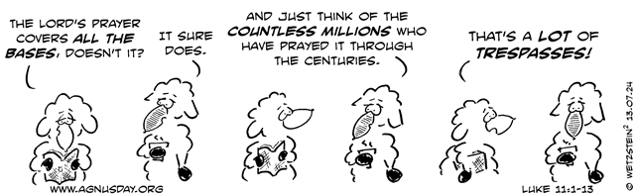

Many, Many thanks to Molly Hollick and all the volunteers who made Vacation Bible School a wonderful and successful event this past week at St. John Evangelical Lutheran Church and for the thirty children and their parents who brought them to Discovery on Adventure Island.

