St. John Evangelical Lutheran Church Sunday, July 31, 2022
229 South Broad Street
Jersey Shore, PA 17740 8th Sunday after Pentecost
570-398-1676
Introduction to the day
Today’s texts offer instruction and encouragement for all who are occasionally overwhelmed by the “unhappy business” of life. Jesus urges us to take care and be on guard against all kinds of greed. We who have died with Christ in holy baptism have also been raised with him and are encouraged to elevate our thinking, seeking the “things that are above.” To that end we seek the sustenance of the Lord’s supper and the encouragement of God’s word.

SHARING OUR JOYS AND CONCERNS

Gathering
The Holy Spirit calls us together as the people of God.

Confession and Forgiveness
The assembly stands. All may make the sign of the cross, the sign that is marked at baptism, as the presiding minister begins.

Blessed be the holy Trinity,☩ one God,
whose steadfast love endures forever.
Amen.
Let us confess our sin in the presence of God and of one another.
Silence is kept for reflection.
Merciful God,
we confess that we have not followed your path
but have chosen our own way.
Instead of putting others before ourselves,
we long to take the best seats at the table.
When met by those in need,
we have too often passed by on the other side.
Set us again on the path of life.
Save us from ourselves
and free us to love our neighbors.

Hear the good news!
God does not deal with us according to our sins
but delights in granting pardon and mercy.
In the name of ☩ Jesus Christ, your sins are forgiven.
You are free to love as God loves. Amen.
GATHERING SONG: Seek Ye First WOV 783
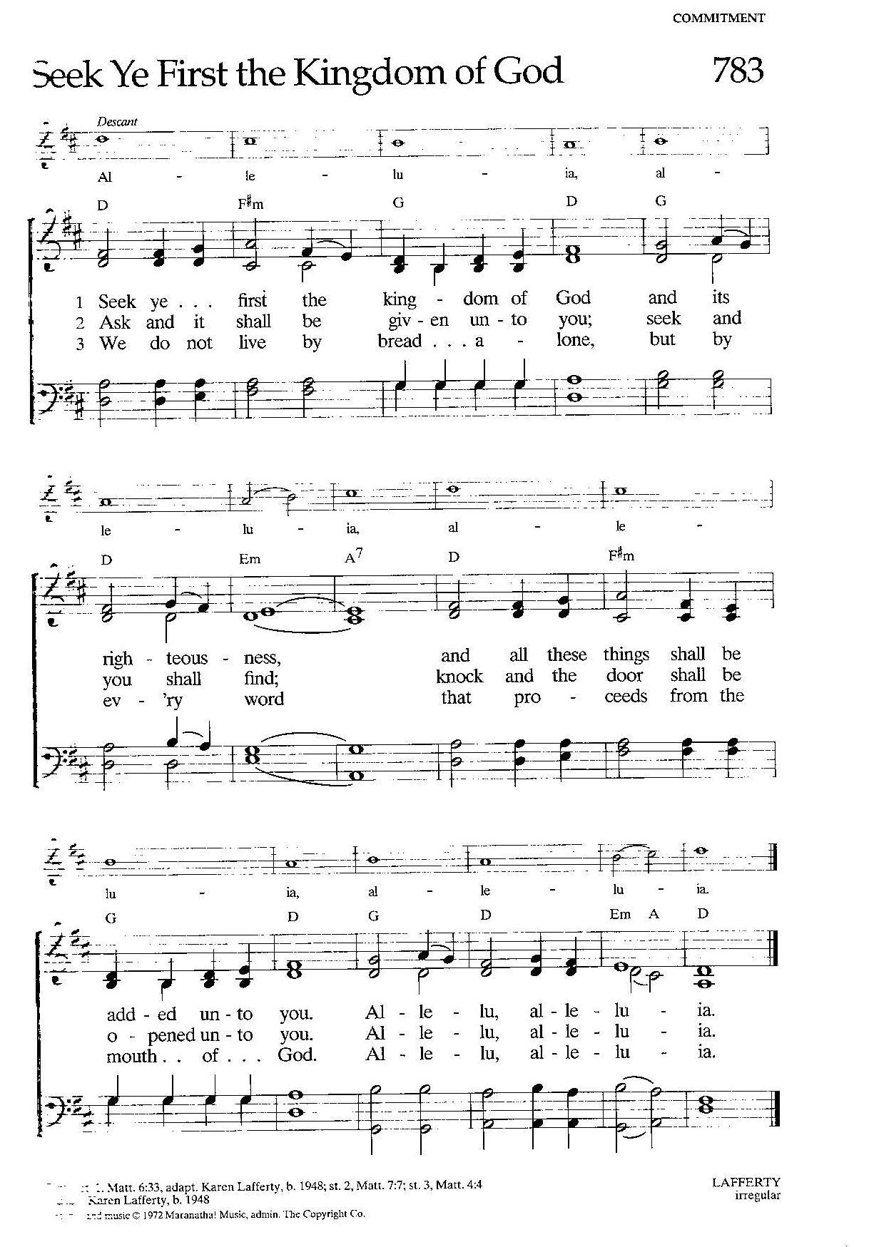

Greeting
P: The grace of our Lord Jesus Christ, the love of God,
and the communion of the Holy Spirit be with you all.

C: And also, with you.

Hymn of PRAISE: We Give Thee but Thine Own 686

Prayer of the Day
P: Let us pray.
Benevolent God, you are the source, the guide, and the goal of our lives. Teach us to love what is worth loving, to reject what is offensive to you, and to treasure what is precious in your sight, through Jesus Christ, our Savior and Lord.
Amen.

The assembly is seated.

Word
God speaks to us in scripture reading, preaching, and song.

L: A reading from Ecclesiastes

First Reading: Ecclesiastes 1:2, 12-14; 2:18-23
The teacher of wisdom who wrote Ecclesiastes sees that working for mere accumulation of wealth turns life into an empty game, a “vanity of vanities.” Nevertheless, he asserts in the next verse, it is good to find enjoyment in one’s work because such enjoyment is a gift from God.

²Vanity of vanities, says the Teacher,
vanity of vanities! All is vanity.
¹²I, the Teacher, when king over Israel in Jerusalem, ¹³applied my mind to seek and to search out by wisdom all that is done under heaven; it is an unhappy business that God has given to human beings to be busy with. ¹⁴I saw all the deeds that are done under the sun; and see, all is vanity and a chasing after wind.
^{2:18}I hated all my toil in which I had toiled under the sun, seeing that I must leave it to those who come after me ¹⁹—and who knows whether they will be wise or foolish? Yet they will be master of all for which I toiled and used my wisdom under the sun. This also is vanity. ²⁰So I turned and gave my heart up to despair concerning all the toil of my labors under the sun, ²¹because sometimes one who has toiled with wisdom and knowledge and skill must leave all to be enjoyed by another who did not toil for it. This also is vanity and a great evil. ²²What do mortals get from all the toil and strain with which they toil under the sun? ²³For all their days are full of pain, and their work is a vexation; even at night their minds do not rest. This also is vanity.
L: The word of the Lord.
C: Thanks be to God.

L: Let us read the Psalm responsively by verse.

Psalm: 49:1-12
¹Hear this, |all you peoples;
give ear, all you who dwell |in the world,
²you of high degree and low,
rich and poor together.
³My mouth shall speak of wisdom,
and my heart shall meditate on understanding.
⁴I will incline my ear to a proverb
and set forth my riddle upon the harp.
⁵Why should I be afraid in evil days,
when the wickedness of those at my heels surrounds me,
⁶the wickedness of those who put their trust in their own prowess,
and boast of their great riches?
⁷One can never redeem another,
or give to God the ransom for another’s life;
⁸for the ransom of a life is so great
that there would never be enough to pay it,
⁹in order to live forever and ever
and never see the grave.
¹⁰For we see that the wise die also; like the dull and stupid they perish
and leave their wealth to those who come after them.
¹¹Their graves shall be their homes forever, their dwelling places from generation to generation,
though they had named lands after themselves.
¹²Even though honored, they cannot live forever;
they are like the beasts that perish.

L: A reading from Colossians

Second Reading Colossians 3:1-11
Life in Christ includes a radical reorientation of our values. Just as the newly baptized shed their old clothes and put on new garments, so Christians are called to let go of greed and take hold of a life shaped by God’s love in Christ.
¹So if you have been raised with Christ, seek the things that are above, where Christ is, seated at the right hand of God. ²Set your minds on things that are above, not on things that are on earth, ³for you have died, and your life is hidden with Christ in God. ⁴When Christ who is your life is revealed, then you also will be revealed with him in glory.
⁵Put to death, therefore, whatever in you is earthly: fornication, impurity, passion, evil desire, and greed (which is idolatry). ⁶On account of these the wrath of God is coming on those who are disobedient. ⁷These are the ways you also once followed, when you were living that life. ⁸But now you must get rid of all such things—anger, wrath, malice, slander, and abusive language from your mouth. ⁹Do not lie to one another, seeing that you have stripped off the old self with its practices ¹⁰and have clothed yourselves with the new self, which is being renewed in knowledge according to the image of its creator. ¹¹In that renewal there is no longer Greek and Jew, circumcised and uncircumcised, barbarian, Scythian, slave and free; but Christ is all and in all!
L: The word of the Lord.
C: Thanks be to God.

The assembly stands.
Gospel Acclamation p.142
Alleluia Lord to whom shall we go?
You have the words of eternal life. Alleluia, Alleluia.

P: The holy gospel according to Luke
C: Glory to you, O Lord.

Gospel: Luke 12:13-21
In God’s reign, the “rich will be sent away empty.” Jesus uses a parable to warn against identifying the worth of one’s life with the value of one’s possessions rather than one’s relationship with God.
¹³Someone in the crowd said to [Jesus,] “Teacher, tell my brother to divide the family inheritance with me.” ¹⁴But he said to him, “Friend, who set me to be a judge or arbitrator over you?” ¹⁵And he said to them, “Take care! Be on your guard against all kinds of greed; for one’s life does not consist in the abundance of possessions.” ¹⁶Then he told them a parable: “The land of a rich man produced abundantly. ¹⁷And he thought to himself, ‘What should I do, for I have no place to store my crops?’ ¹⁸Then he said, ‘I will do this: I will pull down my barns and build larger ones, and there I will store all my grain and my goods. ¹⁹And I will say to my soul, Soul, you have ample goods laid up for many years; relax, eat, drink, be merry.’ ²⁰But God said to him, ‘You fool! This very night your life is being demanded of you. And the things you have prepared, whose will they be?’ ²¹So it is with those who store up treasures for themselves but are not rich toward God.”
P: The gospel of the Lord.
C: Praise to you, O Christ.

The assembly is seated.

Sermon – “Give Thanks for What We Have”

Hymn of the Day: In Christ There Is No East or West 650

Apostles Creed ( p. 105 at the beginning of the hymnal)

Prayers of Intercession
A: Trusting in God’s extraordinary love, let us come near to the Holy One in prayer.
A brief silence.
O God, you are wholeness. Where there is division in your church, bring reconciliation and healing. Guide the work of theologians, Sunday school teachers, seminary professors, and all who provide instruction for the building up of your church. Merciful God,
C: receive our prayer.
A: O God, you are the source of all life. Where creation cries out in distress, bring relief and renewal. Bless farmers, ranchers, distributors, and all who provide our food. Nourish the land and all its habitants. Merciful God,
C: receive our prayer.
A: O God, you are wisdom. Where nations and communities yearn for peace, bring justice. Strengthen those who toil for the welfare of others, especially military personnel, police, first responders, and activists, and for the healing of the nations. Merciful God,
C: receive our prayer.
A: O God, you are life. Where your people are overwhelmed with the busy-ness of life, bring encouragement. Accompany all who experience emotional, mental, or physical distress (especially). Renew us at your table of mercy. Merciful God,
C: receive our prayer.
A: O God, you are our treasure. Where scarcity and anxiety pervade your church, bring abundance and vitality. Guide the work of church councils and committees and give them clarity for the work of ministry in this place (specific ministries may be named). Merciful God,
C: receive our prayer.
A: O God, you are our provider. Where ever are church may be, we send our prayers for outgoing bishop to the Lutheran Church of Liberia, Rev. Jensen Seyenkulo and thank him for his leadership through the Ebola and the global pandemic. May he continue to provide support and council to the new Bishop, Victor Padmore. Merciful God,
C: receive our prayer.
Here other intercessions may be offered.
A: O God, you are resurrection. We give you thanks for all your saints (especially). Inspire us by their example of faithful living to set our minds on things above and to be rich in love toward you. Merciful God,
C: receive our prayer.
P: Receive the prayers of your children, merciful God, and hold us forever in your steadfast love; through Jesus Christ, our holy Wisdom.
Amen.

Responding in Love

Our Offerings This is our response to God's grace.

The assembly stands.
OFFERTORY
Create in me a clean heart, O God, and renew a right spirit with me.
Cast me not away from your presence and take not your Holy Spirit from me.
Restore to me the joy of your salvation, and uphold me with your free Spirit.

Offering Prayer
A: God of abundance:
you have set before us a plentiful harvest.
As we feast on your goodness,
strengthen us to labor in your field,
and equip us to bear fruit for the good of all,
in the name of Jesus. Amen.

gREAT THANKSGIVING p.144 (in the beginning of the hymnal)
Dialogue
Preface by the Pastor
Holy Holy Holy

Thanksgiving at the Table
Words of Institution

Blessed are you, Lord of heaven and earth.
In mercy for our fallen world
you gave your only Son,
that all those who believe in him
should not perish, but have eternal life.
We give thanks to you
for the salvation you have prepared
for us through Jesus Christ.
Send now your Holy Spirit into our hearts,
that we may receive our Lord with a living faith
as he comes to us in his holy supper.

C: Amen. Come, Lord Jesus.

In the night in which he was betrayed,
our Lord Jesus took bread, and gave thanks;
broke it, and gave it to his disciples, saying:
Take and eat; this is my body, given for you.
Do this for the remembrance of me.

Again, after supper, he took the cup, gave thanks,
and gave it for all to drink, saying:
This cup is the new covenant in my blood,
shed for you and for all people for the forgiveness of sin.
Do this for the remembrance of me.

THE LORD’S PRAYER P 145 (in the beginning of the hymnal)

Invitation to Communion
P: In Christ’s presence there is fullness of joy.
Come to the banquet.

Communion
When giving the bread and cup, the communion ministers say
The body of Christ, given for you.
The blood of Christ, shed for you.
and each person may respond Amen.

Communion Song Lamb of God You Take Away p.146

Song after Communion Jesus, Remember Me
Jesus, remember me when you come into your kingdom.
Jesus, remember me when you come into your kingdom.

Prayer after Communion
A: Life-giving God,
through this meal you have bandaged our wounds and fed us with your mercy.
Now send us forth to live for others, both friend and stranger,
that all may come to know your love.
This we pray in the name of Jesus. Amen.

Sending
God blesses us and sends us in mission to the world.

Blessing
The God of peace, Father, ☩ Son, and Holy Spirit,
bless you, comfort you,
and show you the path of life
this day and always. Amen.

Sending Song: God of Grace and God of Glory 705

Dismissal
P: Go in peace. Love your neighbor.
C: Thanks be to God.
Announcements
We welcome our visitors and ask that you sign a Visitor Attendance and Holy Communion Card that is located in the pew rack. We ask that cards be returned via the offering plate during Communion. We offer two choices for Holy Communion, wine or grape juice. Those worshipers desiring grape juice are asked at the communion rail to place their right hand over their heart after receiving “The Body of Christ.”

Remember in prayer: Rowan Aldridge, Dave Barner, Mary Bower, Agnes Cryder, Sarah Davidson, Don Delaney, Mary Ellen Dougherty, Charlie Dunne, Joanne Fisher, William Green, Fred Hoffer, Barbara Hoffman, Jere Hoy, Mick Miller, David Mitchell, Mary Lynn Overdorf, Elsie Parks, Terri Shank, the Snyder family, John Truax, Charles and Candace Welshans, and all of our shut-ins.

We also remember in prayer Family Promise; Bishop Eaton, our Presiding Bishop; and Bishop Collins, Bishop of the Upper Susquehanna Synod soon retiring and Bishop Elect Rev. Craig A. Miller; for our Companion Synod in Liberia and Ansbach-Wurzburg, Germany; and we pray for peace in Ukraine and an end to war.

We pray for the safety of our military troops around the world including Mark Baier, Isaac Boring, Jake Cordrey, Ben Cramer, Trevor and Nehemiah Eberhart, Patrick Hamlin, Paul Laidacker, Kenny Leitch, Steven Moore, Maddison Myers, Tyler O’Neal, Adam Shaffer, Richie Speicher, Aaron Stabley, Paul St. James, and Jenna White.

Special thanks to this week’s helpers: Lector –Pam Wehler; Assisting Ministers –Karen Aucker and Dawn McCloskey; Head Usher –Dawn McCloskey; Teller – Shane Snyder; Bulletin Sponsor – Darlene Bilby.

Next week’s helper: Lector –Kathy Brundrick; Assisting Ministers—Ron Brundick and Deb Heydrich; Head Usher –Kaye Long; Teller –Betty Allen; Bulletin Sponsor – Ruth Aldridge.

The altar flowers are in honor of Donna Penton’s birthday by Shelby and Brett Rice.
The Sanctuary Candle is given in memory of her sister by Myrtle Long.
The Lutheran Church Women’s Prayer Chain is a vital ministry of St. John Lutheran. Anyone in need of prayers is asked to contact any of the following persons:
Gloria Ely – 570-873-3597 Sarah Davidson - 570-398-0659
Joyce Braucht - 570-398-2852

Sight and Sound! Saturday, August 6. Please be at St John Lutheran church at 6:00 a.m.! The Play is at 11:00 a.m. and then a meal at Yoder’s.

IN SEARCH OF a specific ELW (red) Hymnal. Dawn McCloskey cannot find her hymnal. In the back cover is a Penn State sticker and in the hymnal were three obituaries, the one of her father’s was laminated. If you see this hymnal, please bring it to Dawn or the office or the organ.

PANTRY AND KITCHEN ETIQUETTE. The pantry and refrigerator have been cleaned out and all outdated and opened items have been removed. In order to keep the pantry and refrigerator neat and sanitary, please observe the following:
- Any food items that are bought or donated for functions are to be taken back home or given to someone to take. Condiments and unopened beverages may be left for the Food Distribution lunches, if desired. Do NOT store opened food items in the pantry.
- unused plastic ware is to be put back in the appropriate plastic bins, not left out in baskets, where they can become dirty or dusty.
- Unused napkins are to be stored in a designated plastic bin to keep them clean.
Thank you for your cooperation in keeping our pantry and kitchen clean and safe for all to use. The Women of the Church

I would like to thank all those who volunteered their time and effort to make 2022 Vacation Bible School, “Discovery on Adventure Island” a success. I am so grateful that we had 31 children attend the program as they became Explorers on a quest to discover how God’s light shines on us and how we reflect the light as we live each day. Special thanks to Pastor and Karen Aucker, Kaye Long, Pam Wehler, Holly Dittmar, Theresa Levins, Kim Myers, Stephanie Hollick, Gloria Ely, Cathy Eisner, Lisa Ely, Susan Ely, Roman Dittmar, Bob Dittmar, the Women who provided the ice cream social, the congregation for their support and the volunteers from First Methodist Church, Presbyterian Church, and Trinity Episcopal Church, Trinity United Methodist Church .
At a time when many congregations are seeing a decline in the participation of children and youth, we experienced a resurgence of kids’ participation, a “beacon” of hope for the for the future of our youth.
Molly Hollick, VBS Coordinator
Please MARK YOUR CALENDAR FOR:
WOMEN OF THE CHURCH –meeting after the service on Sunday, August 14.
CHRISTIAN ED COMMITTEE – meeting Monday, August 15 at 6:00 p.m.

THIS WEEK’S EVENTS
Sunday, July 31. 2022 8th Sunday after Pentecost
9:30 a.m. Nave Worship Service
Tuesday, August 2, 2022
7:00 p.m. Council
Wednesday, August 3, 2022
10:00 a.m. Trinity Episcopal Worship
Thursday, August 4, 2022
6:30 p.m. VBS wrap-up meeting at St. John
Saturday, August 6, 2022
6:00 a.m. Sight and Sound Bus Trip
Sunday, August 7, 2022 9th Sunday after Pentecost
9:30 a.m. Nave Worship Service

Trinity Lutheran, Avis, Endowment Fund,
Thank you so much for the lovely scholarship money! It came at a perfect time and truly made me feel blessed. I appreciate it beyond words.
God Bless, Devin Lombardo
Devin is in the nursing program through Lackawanna Community College.
Sight and Sound in Lancaster will be airing a live broadcast of David on Friday, September 2 at 7:00 p.m. Download the Sight and Sound app on your computer and you can view the play David through your computer, Ipad, or connect a cable to your TV to show the play through your TV. Cost is $24.99

