St. John Evangelical Lutheran Church Sunday, August 22, 2021
229 South Broad Street 13th Sunday after Pentecost
Jersey Shore, PA 17740
570-398-1676 Blessing of Backpacks, Students & Teachers

Introduction to the day
In today’s gospel many people take offense at Jesus’ invitation to eat his flesh and drink his blood; even many of Jesus’ disciples peel off. This is the backdrop in John’s gospel for Peter’s confession of faith. “To whom can we go?” asks Peter, in words we sometimes sing just before the gospel is read. “You have the words of eternal life.” In order to take such a stand, as Peter and Joshua did, Paul tells us to arm ourselves with the word of God. We pray in the Spirit that we might be bold ambassadors of the gospel.

SHARING OUR JOYS AND CONCERNS

Announcement of the Luke Antolick Benefit Bike Ride September 4 by Penny and Ken Dean.

Blessing of Backpacks, Students & Teachers

Gathering
The Holy Spirit calls us together as the people of God.

Confession and Forgiveness
The assembly stands. All may make the sign of the cross, the sign that is marked at baptism, as the presiding minister begins.

P: Blessed be the holy Trinity,☩ one God,
the God of manna, the God of miracles, the God of mercy.
Amen.

P: Drawn to Christ and seeking God’s abundance,
let us confess our sin.

Silence is kept for reflection.
C: God, our provider, help us. It is hard to believe there is enough to share.
We question your ways when they differ from the ways of the world in which we live. We turn to our own understanding rather than trusting in you. We take offense at your teachings and your ways. Turn us again to you. Where else can we turn? Share with us the words of eternal life and feed us for life in the world.
Amen.
P: Beloved people of God: in Jesus, the manna from heaven, you are fed and nourished. By Jesus, the worker of miracles, there is always more than enough. Through Jesus, ☩ the bread of life, you are shown God’s mercy: you are forgiven and loved into abundant life. Amen.

Gathering Song: You Are the Way 758

Greeting
P: The grace of our Lord Jesus Christ, the love of God,
and the communion of the Holy Spirit be with you all.
C: And also, with you.

Hymn of PRAISE: Spread, Oh, Spread, Almighty Word 663

Prayer of the Day
P: Let us pray.
Holy God, your word feeds your people with life that is eternal. Direct our choices and preserve us in your truth, that, renouncing what is false and evil, we may live in you, through your Son, Jesus Christ, our Savior and Lord.
Amen.

The assembly is seated.

Word
God speaks to us in scripture reading, preaching, and song.

First Reading: Joshua 24:1-2a, 14-18
In the Near East, covenant means “agreement” or “alliance.” It describes relationships and is the primary word used to characterize the relationship between God and Israel. By delivering Israel, God has already begun the relationship. Joshua calls upon the people to respond.

¹Then Joshua gathered all the tribes of Israel to Shechem, and summoned the elders, the heads, the judges, and the officers of Israel; and they presented themselves before God. ^{2a}And Joshua said to all the people, ¹⁴“Now therefore revere the Lord, and serve him in sincerity and in faithfulness; put away the gods that your ancestors served beyond the River and in Egypt, and serve the Lord. ¹⁵Now if you are unwilling to serve the Lord, choose this day whom you will serve, whether the gods your ancestors served in the region beyond the River or the gods of the Amorites in whose land you are living; but as for me and my household, we will serve the Lord.”
¹⁶Then the people answered, “Far be it from us that we should forsake the Lord to serve other gods; ¹⁷for it is the Lord our God who brought us and our ancestors up from the land of Egypt, out of the house of slavery, and who did those great signs in our sight. He protected us along all the way that we went, and among all the peoples through whom we passed; ¹⁸and the Lord drove out before us all the peoples, the Amorites who lived in the land. Therefore we also will serve the Lord, for he is our God.”

L: The word of the Lord.
C: Thanks be to God.

Psalm: Psalm 34:15-22 The eyes of the Lord are upon the righteous. (Ps. 34:15)

¹⁵The eyes of the Lord are up on the righteous,
and God’s ears are open to their cry.
¹⁶The face of the Lord is against those who do evil,
to erase the remembrance of them from the earth.
¹⁷The righteous cry, and the Lord hears them
and delivers them from all their troubles.
¹⁸The Lord is near to the brokenhearted
and saves those whose spirits are crushed.
¹⁹Many are the troubles of the righteous,
but the Lord delivers them from every one.
²⁰God will keep safe all their bones;
not one of them shall be broken.
²¹Evil will bring death to the wicked
and those who hate the righteous will be punished.
²²O Lord, you redeem the life of your servants,
and those who put their trust in you will not be punished.

Second Reading: Ephesians 6:10-20
Like a general giving a rousing speech to troops before battle, this letter closes by calling on Christians to be equipped for spiritual warfare against evil. The full armor of God includes truth, righteousness, peace, faith, the gift of salvation, and the word of God inspired by the Spirit.

¹⁰Be strong in the Lord and in the strength of his power. ¹¹Put on the whole armor of God, so that you may be able to stand against the wiles of the devil. ¹²For our struggle is not against enemies of blood and flesh, but against the rulers, against the authorities, against the cosmic powers of this present darkness, against the spiritual forces of evil in the heavenly places. ¹³Therefore take up the whole armor of God, so that you may be able to withstand on that evil day, and having done everything, to stand firm. ¹⁴Stand therefore, and fasten the belt of truth around your waist, and put on the breastplate of righteousness. ¹⁵As shoes for your feet put on whatever will make you ready to proclaim the gospel of peace. ¹⁶With all of these, take the shield of faith, with which you will be able to quench all the flaming arrows of the evil one. ¹⁷Take the helmet of salvation, and the sword of the Spirit, which is the word of God.
¹⁸Pray in the Spirit at all times in every prayer and supplication. To that end keep alert and always persevere in supplication for all the saints. ¹⁹Pray also for me, so that when I speak, a message may be given to me to make known with boldness the mystery of the gospel, ²⁰for which I am an ambassador in chains. Pray that I may declare it boldly, as I must speak.

L: The word of the Lord.
C: Thanks be to God.

Children’s Sermon –Bread
The assembly stands.

Gospel Acclamation
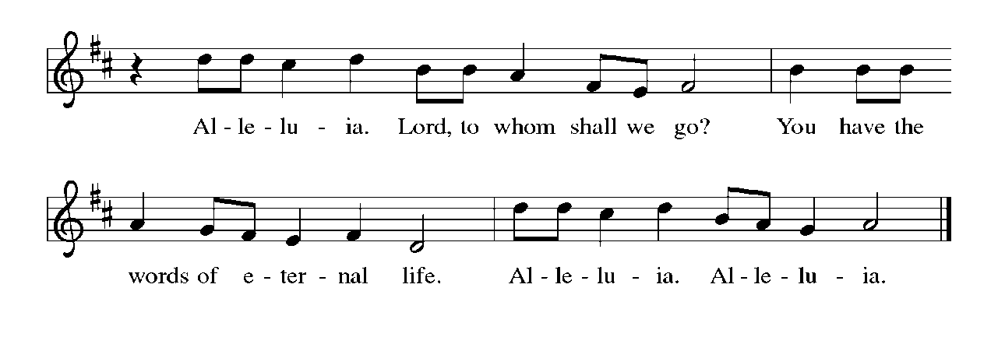

Gospel: John 6:56-69
The “hard saying” that offends Jesus’ disciples is his claim that his followers must eat his flesh and drink his blood. The followers who return to their old lives know something about how odd this sounds. Simon Peter, on the other hand, knows something about the scarcity of living, gracious words. He asks the most important question: “To whom shall we go?”

P: The holy gospel according to John.
C: Glory to you, O Lord.

[Jesus said,] ⁵⁶“Those who eat my flesh and drink my blood abide in me, and I in them. ⁵⁷Just as the living Father sent me, and I live because of the Father, so whoever eats me will live because of me. ⁵⁸This is the bread that came down from heaven, not like that which your ancestors ate, and they died. But the one who eats this bread will live forever.” ⁵⁹He said these things while he was teaching in the synagogue at Capernaum.
⁶⁰When many of his disciples heard it, they said, “This teaching is difficult; who can accept it?” ⁶¹But Jesus, being aware that his disciples were complaining about it, said to them, “Does this offend you? ⁶²Then what if you were to see the Son of Man ascending to where he was before? ⁶³It is the spirit that gives life; the flesh is useless. The words that I have spoken to you are spirit and life. ⁶⁴But among you there are some who do not believe.” For Jesus knew from the first who were the ones that did not believe, and who was the one that would betray him. ⁶⁵And he said, “For this reason I have told you that no one can come to me unless it is granted by the Father.”
⁶⁶Because of this many of his disciples turned back and no longer went about with him. ⁶⁷So Jesus asked the twelve, “Do you also wish to go away?” ⁶⁸Simon Peter answered him, “Lord, to whom can we go? You have the words of eternal life. ⁶⁹We have come to believe and know that you are the Holy One of God.”

P: The gospel of the Lord.
C: Praise to you, O Christ.

The assembly is seated.

Sermon

Hymn of the Day: Blessed Assurance 638
Apostles Creed

I believe in God, the Father almighty,
creator of heaven and earth.
I believe in Jesus Christ, God’s only Son, our Lord,
who was conceived by the Holy Spirit,
born of the virgin Mary,
suffered under Pontius Pilate,
was crucified, died, and was buried;
he descended to the dead.
On the third day he rose again;
he ascended into heaven,
he is seated at the right hand of the Father,
and he will come to judge the living and the dead.
I believe in the Holy Spirit,
the holy catholic church,
the communion of saints,
the forgiveness of sins,
the resurrection of the body,
and the life everlasting. Amen.

Prayers of Intercession

A: Made children and heirs of God’s promise, we pray for the church, the world, and all in need.
A brief silence.
A: God of courage, bless all leaders of your church. Make them ready to proclaim the gospel of peace and strengthen them to preach your loving word. Lord, in your mercy,

C: hear our prayer.

A: God of creation, bless fields and orchards. Protect the land from drought and bring life-giving rain to support growth. Instruct your people in wise treatment of the world you have provided for all your creatures. Lord, in your mercy,

C: hear our prayer.

A: God of community, bless all who seek justice between nations and peoples. Give guidance to bridge-builders, heal divisions, and inspire cooperation in times of crisis, disaster, and war. Lord, in your mercy,

C: hear our prayer.

A: God of compassion, bless all who are in any need. Accompany all who are lonely and feeling abandoned and remind them of your abiding presence. Accompany all who are persecuted and exploited and open us to their cries. Lord, in your mercy,
C: hear our prayer.

A: God of change, bless our transitions. Guide all who are embarking on new stages in life such as a new job, new school, or new community (especially). Sustain enduring friendships and kindle new relationships and interests. Lord, in your mercy,

C: hear our prayer.

Here other intercessions may be offered.
A: God of comfort, bless all who mourn the deaths of their beloved ones. We give you thanks for the saints who have gone before us (especially). Renew our confidence in your promise of resurrection and life in the world to come. Lord, in your mercy,

C: hear our prayer.

P: Receive these prayers, O God, and those in our hearts known only to you; through Jesus Christ our Lord.

C: Amen.

Our Offerings

OFFERATORY
Create in me a clean heart, O God, and renew a right spirit with me.
Cast me not away from your presence and take not your Holy Spirit from me.
Restore to me the joy of your salvation, and uphold me with your free Spirit.

Offering Prayer
A: Jesus, Bread of life, you have set this table with your very self,
and called us to the feast of plenty.
Gather what has been sown among us, and strengthen us in this meal.
Make us to be what we receive here, your body for the life of the world.

C: Amen.

Dialogue
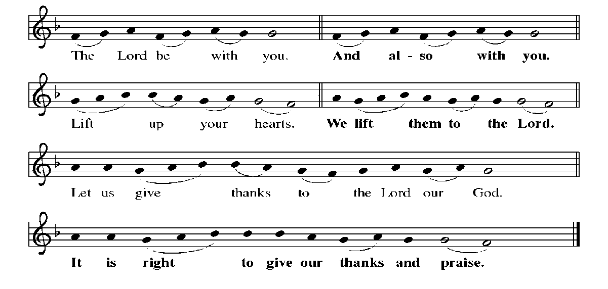

PrefacE By Pastor

HOLY, HOLY, HOLY
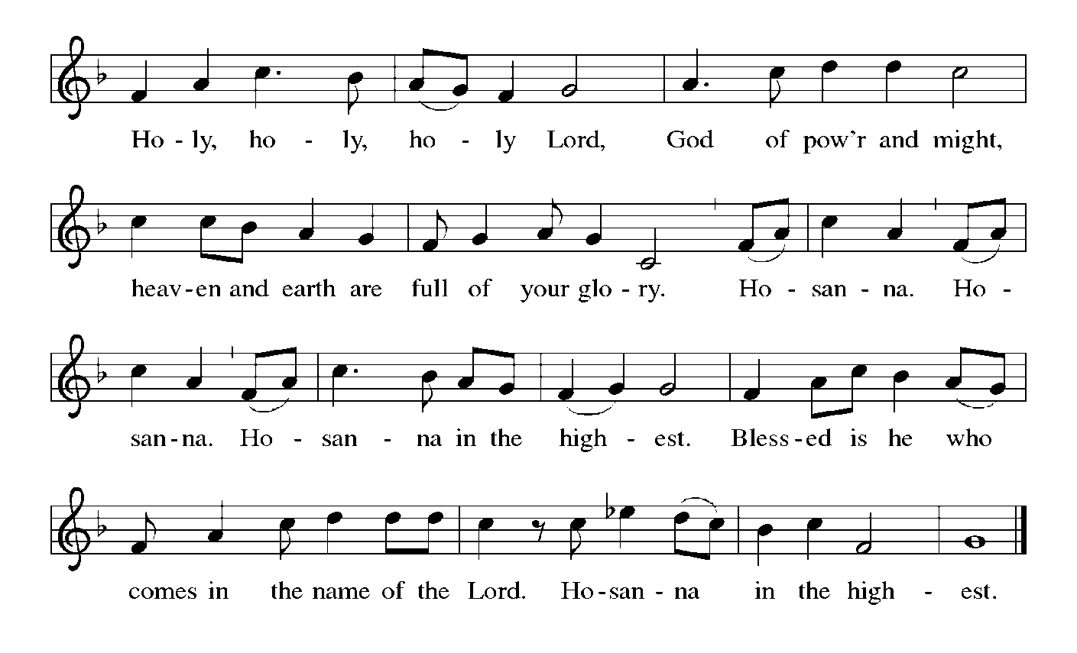

Thanksgiving at the Table
Holy God, holy and mighty, holy and immortal:
you we praise and glorify, you we worship and adore.

You formed the earth from chaos;
you encircled the globe with air;
you created fire for warmth and light;
you nourish the lands with water.
You molded us in your image,
and with mercy higher than the mountains,
with grace deeper than the seas,
you blessed the Israelites and cherished them as your own.

That also we, estranged and dying,
might be adopted to live in your Spirit,
you called to us through the life and death of Jesus.

In the night in which he was betrayed,
our Lord Jesus took bread, and gave thanks;
broke it, and gave it to his disciples, saying:
Take and eat; this is my body, given for you.
Do this for the remembrance of me.

Again, after supper, he took the cup, gave thanks,
and gave it for all to drink, saying:
This cup is the new covenant in my blood,
shed for you and for all people for the forgiveness of sin.
Do this for the remembrance of me.

Together as the body of Christ,
we proclaim the Lord’s death until he comes:
Christ has died.
Christ is risen.
Christ will come again.

With this bread and cup we remember your Son,
the first-born of your new creation.
We remember his life lived for others,
and his death and resurrection, which renews the face of the earth.
We await his coming,
when, with the world made perfect through your wisdom,
all our sins and sorrows will be no more.
Amen. Come, Lord Jesus.

Holy God, holy and merciful one, holy and compassionate,
send upon us and this meal your Holy Spirit,
whose breath revives us for life,
whose fire rouses us to love.
Enfold in your arms all who share this holy food.
Nurture in us the fruits of the Spirit,
that we may be a living tree, sharing your bounty with all the world.
Amen. Come, Holy Spirit.

Holy and benevolent God,
receive our praise and petitions,
as Jesus received the cry of the needy,
and fill us with your blessing,
until, needy no longer and bound to you in love,
we feast forever in the triumph of the Lamb:
through whom all glory and honor is yours, O God, O Living One,
with the Holy Spirit, in your holy church, now and forever.
Amen.

Lord's Prayer
Our Father, who art in heaven,
hallowed be thy name,
thy kingdom come,
thy will be done,
on earth as it is in heaven.
Give us this day our daily bread;
and forgive us our trespasses,
as we forgive those
who trespass against us;
and lead us not into temptation,
but deliver us from evil.
For thine is the kingdom,
and the power, and the glory,
forever and ever. Amen.

Invitation to Communion
P: Christ has set the table with more than enough for all. Come!

Communion
When giving the bread and cup, the communion ministers say
The body of Christ, given for you.
The blood of Christ, shed for you.
and each person may respond Amen.

Communion Song
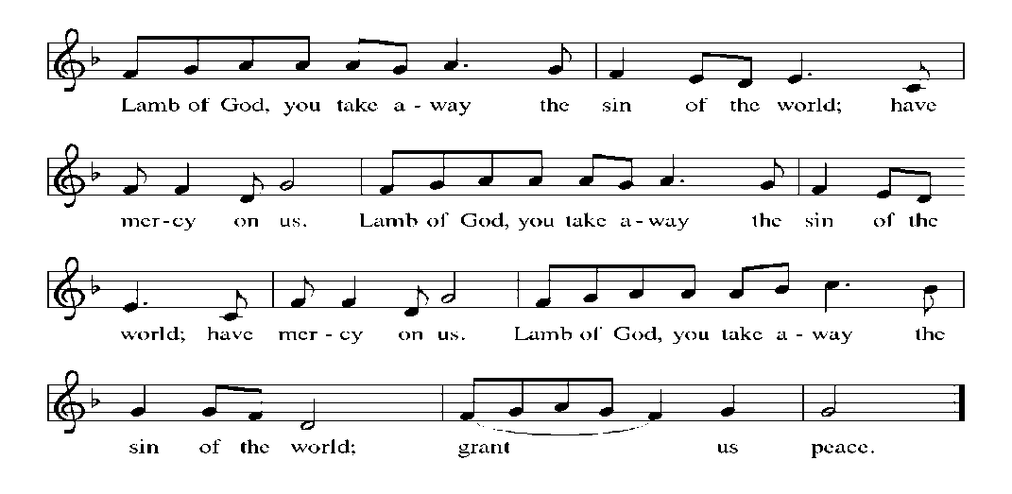

Song after Communion Jesus, Remember Me
Jesus, remember me when you come into your kingdom.
Jesus, remember me when you come into your kingdom.

Prayer after Communion
A: Jesus, Bread of life, we have received from your table more than we could ever ask.
As you have nourished us in this meal, now strengthen us to love the world with your own life.
In your name we pray. C: Amen.
Sending
God blesses us and sends us in mission to the world.

Blessing
P: The blessing of God, who provides for us, feeds us, and journeys with us,
☩ be upon you now and forever.
C: Amen.

Sending Song: How Sweet the Name of Jesus Sounds 620

Dismissal
P: Go in peace. You are the body of Christ.
C: Thanks be to God.

Postlude

There will be a meeting Sunday after worship in the choir room for our shut-in visitors and anyone who would like to volunteer to take the sacrament of Holy Communion to the shut-ins.

Announcements

We welcome our visitors and ask that you sign a Visitor Attendance and Holy Communion Card that is located in the pew rack. We ask that cards be returned via the offering plate during the receiving of the offering. We practice “open Communion” here at St. John meaning that all who believe in the “real presence” of Christ are welcomed to receive the Sacrament of Holy Communion. We offer two choices for Holy Communion, wine or grape juice. Those worshipers desiring grape juice are asked at the communion rail to place their right hand over their heart after receiving “The Body of Christ”.

Remember in prayer: Rowan Aldridge, Luke Antolick, Joanne Fisher, David Kuehl, David Mitchell, Bob and Phyllis Moriarity, Kathy Neal, Ruth Nice, Jean Ann Snyder, Shane Snyder, John Truax, and all of our shut-ins; the safety of our military troops around the world (Mark Baier, Isaac Boring, Jake Cordrey, Richie and Patrick Hamlin, Paul Laidacker, Kenny Leitch, Steven Moore, Maddison Myers, Tyler O’Neal, Adam Shaffer, Aaron Stabley, Paul St. James, Jenna White); Family Promise. Bishop Eaton, our Presiding Bishop; and Bishop Collins, Bishop of the Upper Susquehanna Synod. For our Companion Synod in Liberia and Ansbach-Wurzburg, Germany; and for the New Love Center as it seeks to build a new food hub.

Special Thanks to this week’s helpers :Lector –Deb Heydrich Assisting Ministers –Joyce Braucht and Carl Schaefer; Acolyte –OceAnn Green ; Head Usher - Cozette Stolzfus; Teller-Max Dincher ; Bulletin Sponsor- Dave and Christine Barner ; Bread Sponsor – Dean and Gloria Ely .

Next week’s helpers: Lector–Pam Wehler; Assisting Ministers – Karen Aucker and Dawn McClosky; Acolytes –Andrew Mitchell; Head Usher –Cozette Stolzfus Teller – Max Dincher; Bulletin Sponsor –Dave and Christine Barner; Bread Sponsor – Dean and Gloria Ely; Flowers –Schafer and Miller.
The Sanctuary Candle is sponsored by Myrtle Long during the month of August in loving memory of my sister.

The altar flowers are given in honor of Bob and John Wehler’s birthdays.

Penny and Ken’s Ride for Luke
We invite you to sponsor and support Penny and Ken’s Ride for Luke Antolick on Saturday, September 4 as they ride the Pine Creek Rails to Trails north to Wellsboro Junction and then back to Jersey Shore to support Luke as he continues to undergo treatments and therapy. He has made so much progress thanks to all of you.

Attention all youth! The Eisner family is extending an invitation to all the youth to come to their house, 406 E Campbell Lane, Linden, 570-398-4897, for a swim party Sunday, August 29, starting at 11:30 a.m. We thank them for their hospitality. Please call Cathy if you need further directions to their house.

The Lutheran Church Women’s Prayer Chain is a vital ministry of St. John Lutheran.
Anyone in need of prayers is asked to contact any of the following persons:
Gloria Ely – 570-873-3597
Sarah Davidson - 570-398-0659
Joyce Braucht - 570-398-2852

Choir resumes Wednesday, September 1, 6:30 p.m. Come and share your joyful voices!

“DAVID” playing at Sight and Sound !!
August 6,2022 -- Children 10 and under $125.00; Adults $190.00. Fare includes bus, play, meal, tip for driver and fund raiser for Luke Antolick. Payments may be made during the course of the year! Thank You! Joyce Braucht.

Giving Plus+ Download the “Giving Plus+” app from your app store for your cell phone. This feature is also available on our web site. Enter your email, make up a password, and walk through the choices to give the church an electronic donation by check or debit/credit card. People were asking if they could give electronically by debit/credit card. Now this feature is available. If you have any questions, contact Pastor or Scott Mitchell.

Give+ Text: Simply send a text message to 570-865-1101 with the amount you would like to contribute (example: 25). Within a few minutes, you’ll be sent a text with a link to register. Click on the link and enter your card holder name and credit or debit card information. Once your registration is complete, you will receive a text verification and a receipt of your donation via email. For future giving, send a text with the amount you wish to give, and it will process automatically! You can even text “repeat” to make it a recurring donation. Give+ Text is one of the fastest, easiest ways to give. We hope you enjoy this new way to share your generosity and we thank you for supporting your church.

THIS WEEK’S EVENTS

Sunday, August, 22 2021 13th Sunday after Pentecost
9:30 a.m. Nave Worship Service
7:00 p.m. NA meeting
Monday, August 23, 2021
7:30 P.M. NA meeting
Wednesday, August 25, 2021
10:00 a.m. Communion Trinity Episcopal Church
Friday, August 27, 2021
9:00 a.m.-1:00 p.m. Food Distribution
Sunday, August 29, 2021 14th Sunday after Pentecost
9:30 a.m. Nave Worship Service
11:30 a.m. Youth Swim at Eisner’s
7:00 p.m. NA meeting

