St. John Evangelical Lutheran Church Sunday, October 30, 2022
229 South Broad Street Reformation Sunday
Jersey Shore, PA 17740
570-398-1676

We welcome the Fairplay Brass to our Reformation Festival. We sincerely appreciate and are thankful for their generosity in sharing their gifted talents. A basket for thank-offerings for them is on the piano.

Reformation Day
By the end of the seventeenth century, many Lutheran churches celebrated a festival commemorating Martin Luther's posting of the Ninety-five Theses, a summary of abuses in the church of his time. At the heart of the reform movement was the gospel, the good news that it is by grace through faith that we are justified and set free.
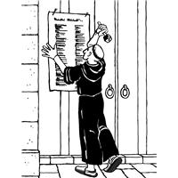
Introduction to the day
“God loves us all, both big and small,” a child’s verse declares. The sins of the world are covered. We are able to stand tall before God our righteous judge because in the person of Jesus “salvation has come to this house”—to our house today. In Christ Jesus God seeks us out to save us..

SHARING OUR JOYS AND CONCERNS

Prelude

Gathering
The Holy Spirit calls us together as the people of God.

Confession and Forgiveness
The assembly stands. All may make the sign of the cross, the sign that is marked at baptism, as the presiding minister begins.
Blessed be the holy Trinity, ☩ one God,
who is eager to forgive
and who loves us beyond our days.
Amen.
Dear friends, together let us acknowledge
our failure to love this world as Jesus does.
Silence is kept for reflection.
God of mercy and forgiveness,

we confess that sin still has a hold on us.
We have harmed your good creation.
We have failed to do justice,
love kindness,
and walk humbly with you.
Turn us in a new direction.
Show us the path that leads to life.
Be our refuge and strength on the journey,
through Jesus Christ, our redeemer and friend.
Amen.

Beloved of God:
your sins are forgiven ☩ and you are made whole.
God points the way to new life in Christ,
who meets us on the road.
Journey now in God’s abiding love
through the power of the Holy Spirit.
Amen.

GATHERING SONG: A Mighty Fortress Is Our God 504

Greeting
P: The grace of our Lord Jesus Christ, the love of God,
and the communion of the Holy Spirit be with you all.
C: And also, with you.

Hymn of PRAISE: This Is the Feast p.140

Prayer of the Day
P: Let us pray.
Almighty God, gracious Lord, we thank you that your Holy Spirit renews the church in every age. Pour out your Holy Spirit on your faithful people. Keep them steadfast in your word, protect and comfort them in times of trial, defend them against all enemies of the gospel, and bestow on the church your saving peace, through Jesus Christ, our Savior and Lord, who lives and reigns with you and the Holy Spirit, one God, now and forever.
Amen.
The assembly is seated.

Word
God speaks to us in scripture reading, preaching, and song.

A reading from Jeremiah.

First Reading: Jeremiah 31:31-34
The renewed covenant will not be breakable, but like the old covenant it will expect the people to live upright lives. To know the Lord means that one will defend the cause of the poor and needy (Jer. 22:16). The renewed covenant is possible only because the Lord will forgive iniquity and not remember sin. Our hope lies in a God who forgets.
³¹The days are surely coming, says the Lord, when I will make a new covenant with the house of Israel and the house of Judah. ³²It will not be like the covenant that I made with their ancestors when I took them by the hand to bring them out of the land of Egypt—a covenant that they broke, though I was their husband, says the Lord. ³³But this is the covenant that I will make with the house of Israel after those days, says the Lord: I will put my law within them, and I will write it on their hearts; and I will be their God, and they shall be my people. ³⁴No longer shall they teach one another, or say to each other, “Know the Lord,” for they shall all know me, from the least of them to the greatest, says the Lord; for I will forgive their iniquity, and remember their sin no more.

L: The word of the Lord.
C: Thanks be to God.

L: Let us read the Psalm responsively by verse.

Psalm: Psalm 46
The Lord of hosts is with us; the God of Jacob is our stronghold. (Ps. 46:7)
¹God is our ref- | uge and strength,
a very present | help in trouble.
²Therefore we will not fear, though the | earth be moved,
and though the mountains shake in the depths | of the sea;
³though its waters | rage and foam,
and though the mountains tremble | with its tumult.
⁴There is a river whose streams make glad the cit- | y of God,
the holy habitation of | the Most High.
⁵God is in the midst of the city; it shall | not be shaken;
God shall help it at the | break of day.
⁶The nations rage, and the | kingdoms shake;
God speaks, and the earth | melts away. R
⁷The Lord of | hosts is with us;
the God of Jacob | is our stronghold.
⁸Come now, regard the works | of the Lord,
what desolations God has brought up- | on the earth;
⁹behold the one who makes war to cease in | all the world;
who breaks the bow, and shatters the spear, and burns the | shields with fire.
¹⁰“Be still, then, and know that | I am God;
I will be exalted among the nations; I will be exalted | in the earth.”
¹¹The Lord of | hosts is with us;
the God of Jacob | is our stronghold. R

L: A reading from Romans, the third chapter.

Second Reading: Romans 3:19-28
Paul’s words stand at the heart of the preaching of Martin Luther and other Reformation leaders. No human beings make themselves right with God through works of the law. We are brought into a right relationship with God through the divine activity centered in Christ’s death. This act is a gift of grace that liberates us from sin and empowers our faith in Jesus Christ.
¹⁹Now we know that whatever the law says, it speaks to those who are under the law, so that every mouth may be silenced, and the whole world may be held accountable to God. ²⁰For “no human being will be justified in his sight” by deeds prescribed by the law, for through the law comes the knowledge of sin.
²¹But now, apart from law, the righteousness of God has been disclosed, and is attested by the law and the prophets, ²²the righteousness of God through faith in Jesus Christ for all who believe. For there is no distinction, ²³since all have sinned and fall short of the glory of God; ²⁴they are now justified by his grace as a gift, through the redemption that is in Christ Jesus, ²⁵whom God put forward as a sacrifice of atonement by his blood, effective through faith. He did this to show his righteousness, because in his divine forbearance he had passed over the sins previously committed; ²⁶it was to prove at the present time that he himself is righteous and that he justifies the one who has faith in Jesus.
²⁷Then what becomes of boasting? It is excluded. By what law? By that of works? No, but by the law of faith. ²⁸For we hold that a person is justified by faith apart from works prescribed by the law.

L: The word of the Lord.
C: Thanks be to God.
The assembly stands.
Gospel Acclamation p.142
Alleluia Lord to whom shall we go?
You have the words of eternal life. Alleluia, Alleluia.

P: The holy gospel according to Luke.
C: Glory to you, O Lord,

Gospel: John 8:31-36
Jesus speaks of truth and freedom as spiritual realities known through his word. He reveals the truth that sets people free from sin.
³¹Jesus said to the Jews who had believed in him, “If you continue in my word, you are truly my disciples; ³²and you will know the truth, and the truth will make you free.” ³³They answered him, “We are descendants of Abraham and have never been slaves to anyone. What do you mean by saying, ‘You will be made free’?”
³⁴Jesus answered them, “Very truly, I tell you, everyone who commits sin is a slave to sin. ³⁵The slave does not have a permanent place in the household; the son has a place there forever. ³⁶So if the Son makes you free, you will be free indeed.”

P: The gospel of the Lord.
C: Praise to you, O Christ.

The assembly is seated.
Sermon “Dr. Luther and Katie” by Pastor and Mrs. Aucker
Hymn of the Day: God of Our Fathers (from LBW)
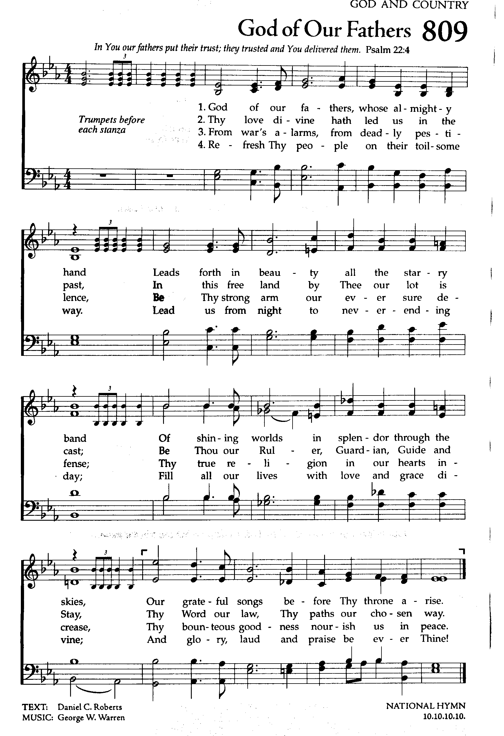
THE NICENE CREED

We believe in one God,
the Father, the Almighty,
maker of heaven and earth,
of all that is, seen and unseen.
We believe in one Lord, Jesus Christ,
the only Son of God,
eternally begotten of the Father,
God from God, Light from Light,
true God from true God,
begotten, not made,
of one Being with the Father;
through him all things were made.
For us and for our salvation
he came down from heaven,
was incarnate of the Holy Spirit and the virgin Mary
and became truly human.
For our sake he was crucified under Pontius Pilate;
he suffered death and was buried.
On the third day he rose again
in accordance with the scriptures;
he ascended into heaven
and is seated at the right hand of the Father.
He will come again in glory to judge the living and the dead,
and his kingdom will have no end.
We believe in the Holy Spirit, the Lord, the giver of life,
who proceeds from the Father and the Son,*
who with the Father and the Son is worshiped and glorified,
who has spoken through the prophets.
We believe in one holy catholic and apostolic church.
We acknowledge one baptism for the forgiveness of sins.
We look for the resurrection of the dead,
and the life of the world to come. Amen.

Prayers of Intercession
A: In gratitude and humility, let us join together in prayer on behalf of all of God’s creation
.A brief silence
Keep your church steadfast in your word, reforming God. Deepen our faith and increase our love in Jesus’ name. Further ecumenical dialogue and partnerships (local partnerships may be named) and equip us for unified witness and service in the world. Hear us, O God.
C: Your mercy is great.
A: Come to the aid of the poor, especially those suffering food and water shortages or loss of homes due to natural disasters. Halt the exploitation of the earth’s resources and lead us to seek justice and rescue the oppressed. Hear us, O God.
C: Your mercy is great.
A: Guide leaders of all nations, almighty God. Heal divisions, build trust, and remove barriers that prevent collaboration and cooperation. Bring neighborhoods, cities, and countries together to work for the common good. Hear us, O God.
C: Your mercy is great.
A: Save from trouble those who struggle with hunger, homelessness, or addiction. Strengthen the overworked and give hope to those who do not have enough work. Console those who are burdened by illness or grief (especially). Hear us, O God.
C: Your mercy is great.
A: Reveal yourself to all who seek you. Empower the hospitality ministries of this congregation to welcome others to your feast of love. Foster generosity in our stewardship ministries to both our congregation and community. Hear us, O God.
C: Your mercy is great.
A: Gracious God, in this time of Reformation, help us to remember your love, grace and mercy for all God’s people around the world. We pray for the work and ministry of Lutheran World Federation. Hear us, O God.
C: Your mercy is great.
Here other intercessions may be offered.
A: Gather the faithful at the table of your eternal banquet. We give thanks for those who have witnessed to your gracious presence, especially Martin Luther and all who strive to reform and renew the church. Hear us, O God.
C: Your mercy is great.
P: With grateful hearts we commend our spoken and silent prayers to you, O God; through Jesus Christ, our Lord.
Amen.

Our Offerings of Music

FAIRPLAY BRASS

CHOIR ANTHEM O For Grace

OFFERTORY
Create in me a clean heart, O God, and renew a right spirit with me.
Cast me not away from your presence and take not your Holy Spirit from me.
Restore to me the joy of your salvation, and uphold me with your free Spirit.

Offering Prayer
A: Gracious God,
in your great love you richly provide for our needs.
Make of these gifts a banquet of blessing,
and make us ready to share with all in need;
through Jesus Christ, who sets a table for all. Amen.

gREAT THANKSGIVING p.144 (in the beginning of the hymnal)
Dialogue
Preface by the Pastor
Holy Holy Holy

Thanksgiving at the Table
Words of Institution

Holy God, mighty Lord, gracious Father:
Endless is your mercy and eternal your reign.
You have filled all creation with light and life;
heaven and earth are full of your glory.

We praise you for the grace shown to your people in every age;
the promise to Israel, the rescue from Egypt,
the gift of the promised land,
the words of the prophets; and, at this end of all ages,
the gift of you Son, who proclaimed the good news in word and deed
and was obedient to your will, even to giving his life.

In the night in which he was betrayed,
our Lord Jesus took bread, and gave thanks;
broke it, and gave it to his disciples, saying:
Take and eat; this is my body, given for you.
Do this for the remembrance of me.

Again, after supper, he took the cup, gave thanks,
and gave it for all to drink, saying:
This cup is the new covenant in my blood,
shed for you and for all people for the forgiveness of sin.
Do this for the remembrance of me.
For as often as we eat of this bread and drink from this cup,
we proclaim the Lord’s death until he comes.

Christ has died.
Christ is risen.
Christ will come again.

Therefore, O God, with this bread and cup
we remember the life our Lord offered for us.
And, believing the witness of his resurrection,
we await his coming in power to share with us the great and promised feast.

Amen. Come, Lord Jesus.

Send now, we pray, your Holy Spirit, that we who share
in Christ’s body and blood and may live to the praise of your glory
and receive our inheritance with all your saints in light.

Amen. Come, Holy Spirit.

Join our prayers with those of your servants of every time and every place,
and unite them with the ceaseless petitions of our great high priest
until he comes as victorious Lord of all.
Through him, with him, in him, in the unity of the Holy Spirit,
all gory and honor is yours, almighty Father, now and forever.

Amen.

Lord's Prayer
Our Father, who art in heaven,
hallowed be thy name,
thy kingdom come,
thy will be done,
on earth as it is in heaven.
Give us this day our daily bread;
and forgive us our trespasses,
as we forgive those
who trespass against us;
and lead us not into temptation,
but deliver us from evil.
For thine is the kingdom,
and the power, and the glory,
forever and ever. Amen.
Invitation to Communion
P: Christ invites you to this table.
Come, taste and see.

Communion
When giving the bread and cup, the communion ministers say
The body of Christ, given for you.
The blood of Christ, shed for you.
and each person may respond Amen.

Communion Song Lamb of God You Take Away p.146

Communion
When giving the bread and cup, the communion ministers say
The body of Christ, given for you.
The blood of Christ, shed for you.
and each person may respond Amen.

Communion Song (p.146)

Song after Communion Jesus, Name Above All Names
(repeat twice)
Jesus, name above all names, beautiful Savior, glorious Lord,
Emmanuel, God is with us, blessed Redeemer, living Word

Prayer after Communion
A: God of the abundant table,
you have refreshed our hearts in this meal
with bread for the journey.
Give us your grace on the road
that we might serve our neighbors with joy;
for the sake of Jesus Christ, our Lord. Amen

Sending
God blesses us and sends us in mission to the world.

Blessing
P: God, who gives life to all things
and frees us from despair,
bless you with truth and peace.
And may the holy Trinity, ☩ one God,
guide you always in faith, hope, and love. Amen.

Sending Song: The Church’s One Foundation 654

Dismissal
P: Go in peace, with Christ beside you.
C: Thanks be to God.

POSTLUDE The Fairplay Brass
{Please remain seated until they finish playing}
{An offering basket is up front on the piano if you wish to leave them a donation}

Dismissal
P: Go in peace, with Christ beside you.
C: Thanks be to God.

Announcements
We welcome our visitors and ask that you sign a Visitor Attendance and Holy Communion Card that is located in the pew rack. We ask that cards be returned via the offering plate during Communion. We offer two choices for Holy Communion, wine or grape juice. Those worshipers desiring grape juice are asked at the communion rail to place their right hand over their heart after receiving “The Body of Christ.”

Remember in prayer: Rowan Aldridge, Dave Barner, Agnes Cryder, Sarah Davidson, Don & Helen Delaney, Joanne Fisher, Beth Good, Fred Hoffer, Ralph Lehman, Mick Miller, David Mitchell, Mary Lynn Overdorf, the Snyder family, and all of our shut-ins.

We also remember in prayer Family Promise; Presiding Bishop Elizabeth Eaton – ELCA; Bishop Craig A. Miller - USS; for our Companion Synods in Liberia and Ansbach-Wurzburg, Germany; and we pray for peace in Ukraine and an end to war.

We pray for the safety of our military troops around the world including Mark Baier, Isaac Boring, Jake Cordrey, Ben Cramer, Trevor and Nehemiah Eberhart, Patrick Hamlin, Paul Laidacker, Kenny Leitch, Steven Moore, Maddison Myers, Tyler O’Neal, Adam Shaffer, Richie Speicher, Aaron Stabley, Paul St. James, and Jenna White. We also lift up in prayer their families who strife to keep a normalcy in the family and continue on often with added stress.

Special thanks to this week’s helper: Lector –Deb Heydrich; Assisting Ministers Karen Aucker, Cozette Stoltzfus; Head Usher –Shane Snyder; Teller –Dawn McCloskey; Bulletin Sponsor – Jean Ann Snyder; Children’s Church – volunteer needed; Flowers--Cynthia Breon.
Next week’s helpers: Lector – Kathy Brundick; Assisting Ministers – Deb Heydrich, Ron Brundick, Head Usher – Christine Barner; Teller – Gina Johnson; Bulletin Sponsor—; Children’s Church – Pam Wehler ; Flowers – JOY Class.

The altar flowers are given to the glory of God and in loving memory of my parents Harris and Winifred Barner by Cynthia Breon.

The Sanctuary Candle is given in memory of her husband Malcolm by Joyce Hudson.

The Lutheran Church Women’s Prayer Chain is a vital ministry of St. John Lutheran. Anyone in need of prayers is asked to contact any of the following persons: Gloria Ely – 570-873-3597 Sarah Davidson - 570-398-0659
Joyce Braucht - 570-398-2852

A BIG THANK YOU to all that helped with the First Responders Dinner—everyone who helped set up, who donated, who cooked, who served, and who helped clean up. Thank you!

WOMEN OF THE CHURCH will meet Sunday, November 6 after the service to tie up final plans for the Bazaar.

Christian Education is seeking volunteers to lead Children’s Church once a month. If interested please see Cathy Eisner. The 4th and 5th Sundays are open.

Please join us in remembering our members who have entered into the Resurrection Life this past year on November 6:
Leila Hiller December 9, 2021
Richard Dershem February 19, 2022
Lower Wagner March 26, 2022

Bible Study will continue on Mondays at 1:00 p.m. We are covering Proverbs/Ch6

The Christian Education Committee is happy to announce that Adult Sunday School classes has resumed meeting. The class will be held from 8:30 am – 9:15 am in the Adult Sunday School area and this class is open to everyone. Class materials will be provided to all those who want to participate.

VOLUNTEERS NEEDED TO RESUME NURSERY. We are in need of adult and teen volunteers to supervise toddlers/babies in the nursery during church. Please contact Molly Hollick, or Ken Dougherty if you would be willing to help out or have any questions. Our hope is to get enough volunteers to have a monthly rotation cycle.

Fall Cash Sunday Offering is November 6. This year’s offering will go towards the purchase of a new computer and the newest operating system. A mailing was sent out to the congregation or you can place your donation in an envelope with your name and mark it Fall Cash Sunday. Your support for Fall Cash Sunday is greatly appreciated.

Harvest Home Sunday, November 13. The theme will be “Thanks for all we Have.” Each year we receive donations of food and place them in the front of the sanctuary. This year the food donations will be kept here at St. John Lutheran to serve the emergency food needs of people locally. Your generosity is appreciated.

The annual Endowment Committee meeting is scheduled for November 13, 2022, following the worship service.

Remember the deadline for the December/January newsletter is November 15. Please submit your articles early to the church office.

There will be a short Congregation Meeting following the service on Sunday, November 20. It will be our annual meeting to elect council members, synod delegates, Trinity Endowment members, and the 2023 budget.

Mark your calendar! The Annual Christmas Bazaar will be December 10, 2022 9:00 a.m. to 1:00 p.m.

Youth Ministry

This afternoon. All Hallows Eve Party, 4-6 pm. For our younger youth.

This afternoon. Pine Creek Corn Maize. 4:00 p.m. Meet in Avis at the Corn Maze registration table at 4:00 p.m. For all Middle and High School youth.

For Elementary youth: Sunday, November 13 after worship, Mrs. Eisner will be demonstrating making apple desserts. Please meet in the kitchen.

THIS WEEK’S EVENTS

Sunday, October 30, 2022 Reformation Sunday
8:30 a.m. Adult Sunday School Class
9:30 a.m. Nave Worship Service. With the Fairplay Brass
4:00 p.m. Corn Maize - Middle and High School Youth
4:00 – 6:00 p.m. All Hallow’s Eve Elementary Youth at St. John

Monday, October 31, 2022
1:00 p.m. Bible Study
Tuesday, November 1, 2022
2:00 p.m. Communions at Promedica. Mrs. Cozette Stoltzfus and Pastor Aucker will be offering the Sacrament of Holy Communion to the residents of Promedica,
7:00 pm Council meeting.
Wednesday, November 2, 2022
10:00 a.m. Trinity Episcopal Worship. You are invited to attend.
6:30 p.m. Choir rehearsal “Join the Choir Night!”
Sunday, November 6. 2022 All Saints Sunday
8:30 a.m. Adult Sunday School Class
9:30 a.m. Children’s Church
9:30 a.m. Nave Worship Service. Fall Cash Sunday
10:30 a.m. Women of the Church Meeting

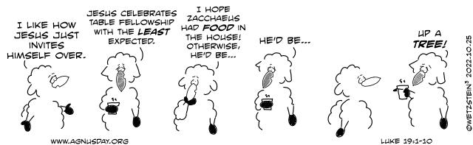

Reminder: Seafarer Satchels must be turned into the office by Tuesday morning, November 1 so we can take them to the Synod office. If you still wish to assemble a Seafarer bag, bags are available on the tower pew. Items for in the bag are in this bulletin as an insert. This was an important ministry to Rev. Martha McCracken who was President of Seafarers International and a daughter of this congregation.

